

**Release Document for Self-Driving Rental Car Application in Pega**

Proof Of Concept



November 25, 2023

Shriram.k

**Table of Contents:**

1. **Introduction**
2. **Background**
3. **Purpose**
4. **Scope**
5. **Key Features**

5.1 Single Sign-on(SSO)  
5.2 Google Map integration  
5.3 Mashup  
5.4 Email Listener  
5.5 Email Generation  
5.6 File Upload

1. **End to end functionalities with screenshots.**

6.1 Booking case type

6.2 History case type

1. **Enhancements and Bug.**

7.1 List of Enhancements  
7.2 List of Bug

1. **System requirements.**
2. **Release Sign-Off**
3. **Conclusion**

**1. Introduction:**

The Self-Driving Rental Car Application POC is a pioneering initiative aimed at showcasing the robust capabilities of the Pega BPM platform in revolutionizing the rental car industry within the dynamic landscape of India. I am excited to express my interest in the Self-Driving Car Application Proof of Concept (POC) opportunity in PEGA. I am particularly enthusiastic about the prospect of working on this project as it combines my passion for innovative technologies and my deep understanding of PEGA. Leveraging my hands-on experience, I am well-equipped to tackle the challenges and complexities associated with developing a self-driving car application, ensuring its seamless integration within the PEGA platform.

**2.** **Background:**

The Self-Driving Rental Car Application leverages the Pega platform to offer a seamless and intelligent experience for users.

**3. Purpose:**

The purpose of conducting a Proof of Concept (POC) in Pega for a self-driving car application is to leverage Pega's capabilities in understanding and implementing the major rules associated with autonomous driving. By using Pega, we aim to validate and demonstrate the effectiveness of its rule-based decision-making approach in managing complex scenarios that arise in autonomous vehicles.

**4. Scope:**

The scope encompasses the key features, system requirements, deployment instructions, testing procedures, known issues, and the sign-off process.

**5. Key Features:**

**5.1 Single Sign-On (SSO):**

Single signon (SSO) in Pega is the ability for users to log in once to access multiple applications or systems without having to log in again. Pega provides SSO support through multiple authentication methods. SSO integration features vary depending on your organization's policies and the identity service provider (IdP) you use.

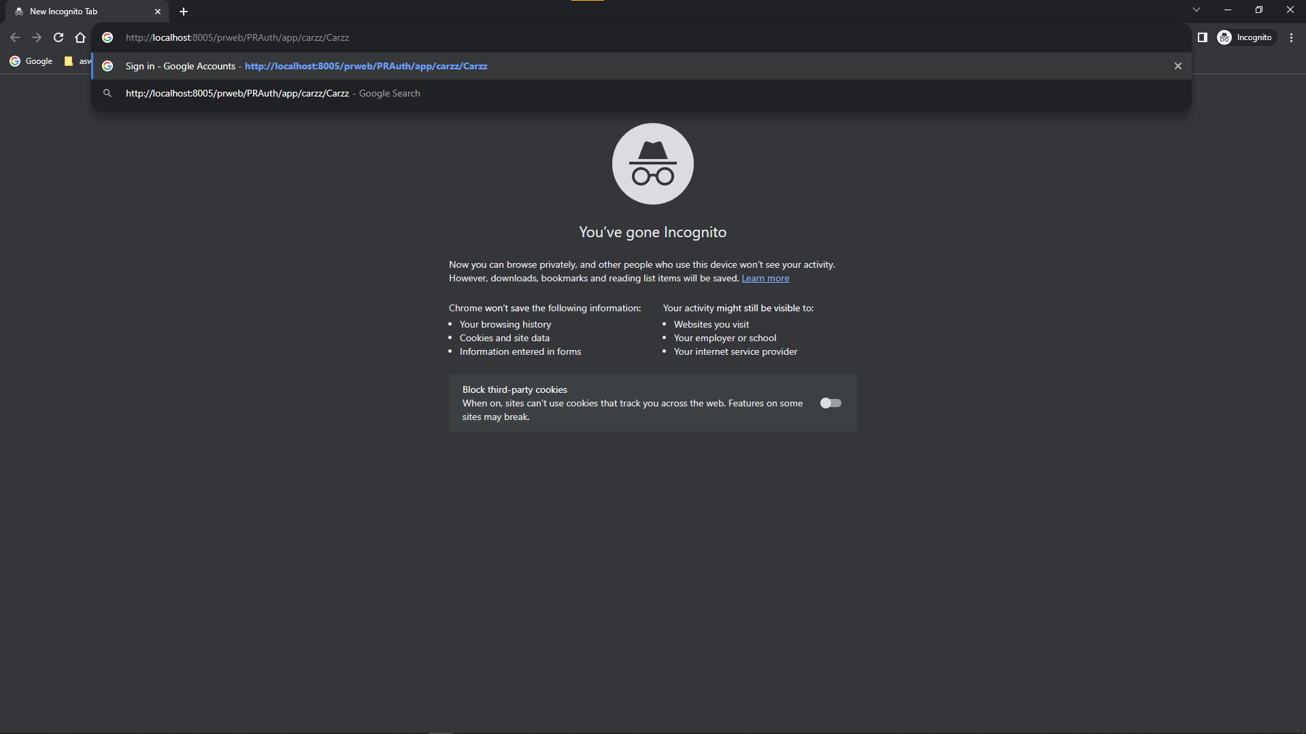

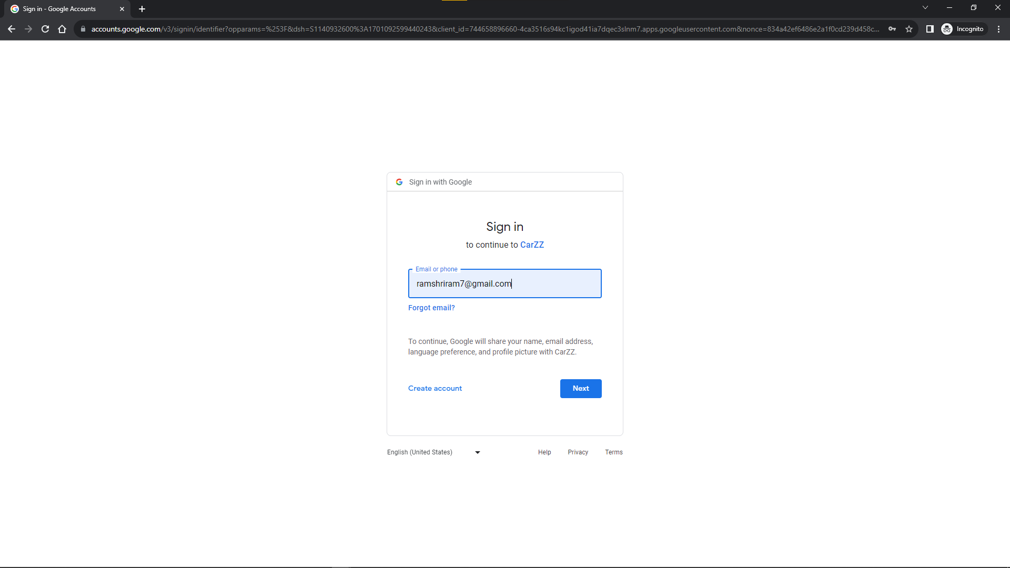

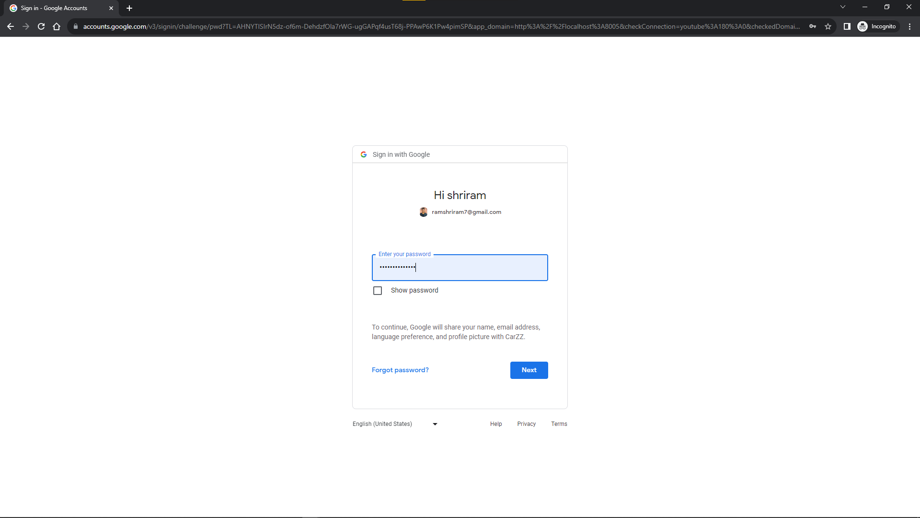

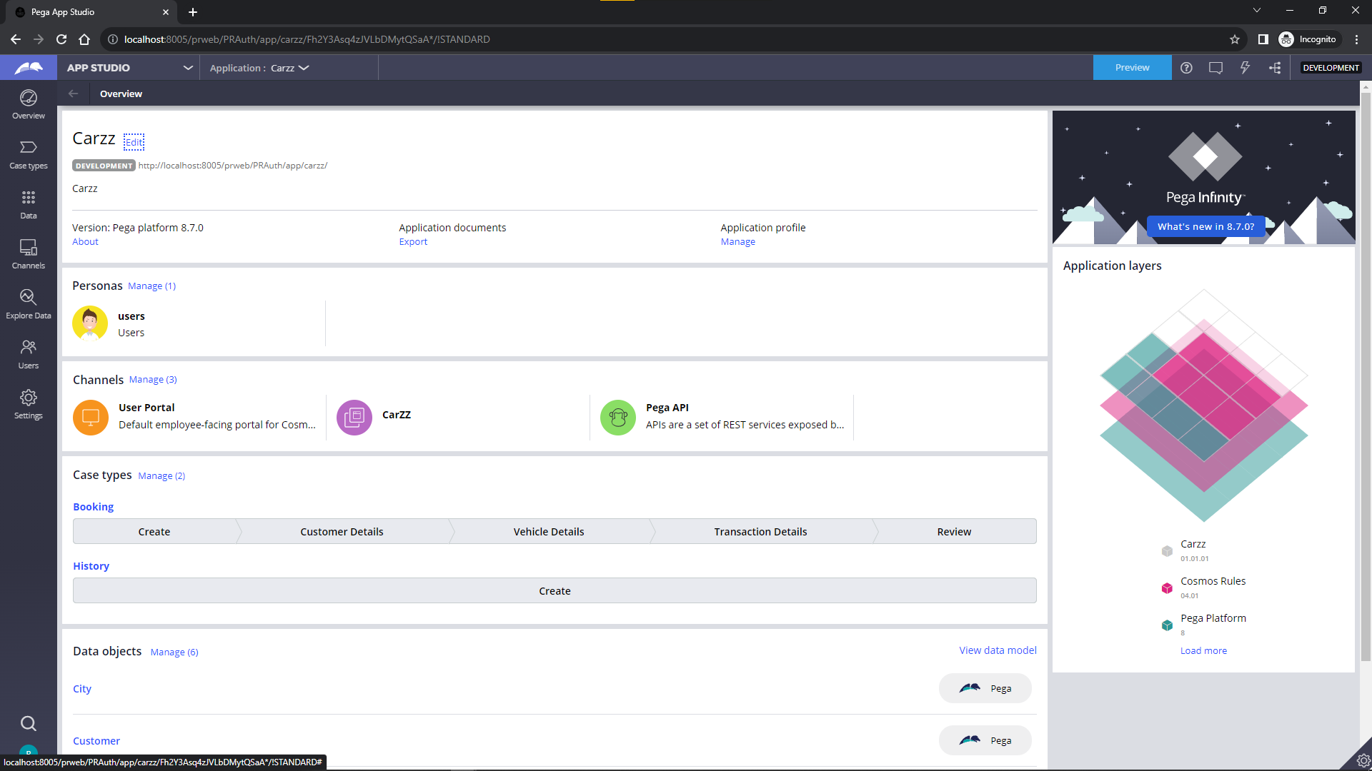

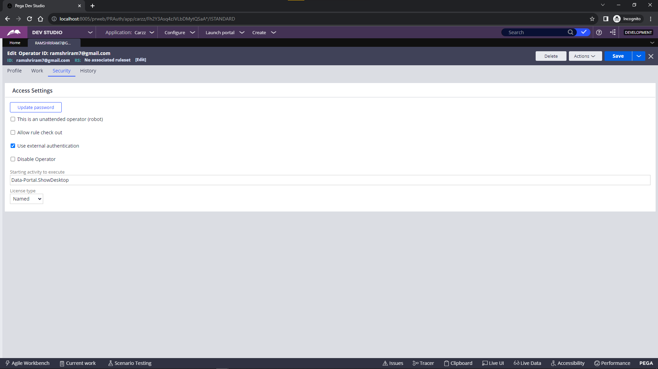

**5.2 Google map integration**

Integrating Google Maps into a Pega application can enhance the user experience by providing location-based services and visual representations of geographical data.

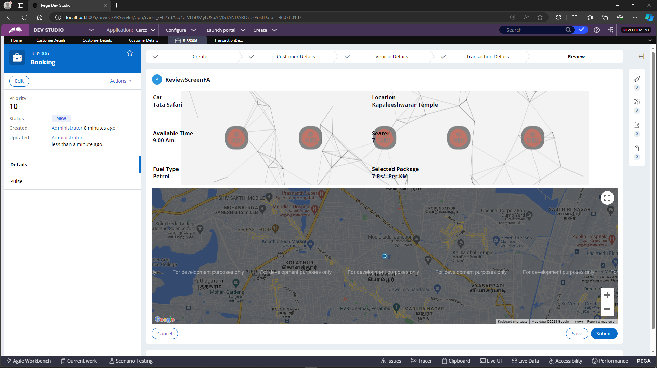

**5.3 Mashup:**

Pega Mashup is a powerful feature that enables seamless integration of Pega applications into external websites or portals. With Pega Mashup, organizations can extend the reach of their Pega applications beyond traditional boundaries, allowing users to interact with Pega functionality directly within other web environments. This capability enhances the user experience by embedding Pega components such as forms, dashboards, and case management directly into external web pages, fostering a cohesive and unified user interface across diverse digital platforms.

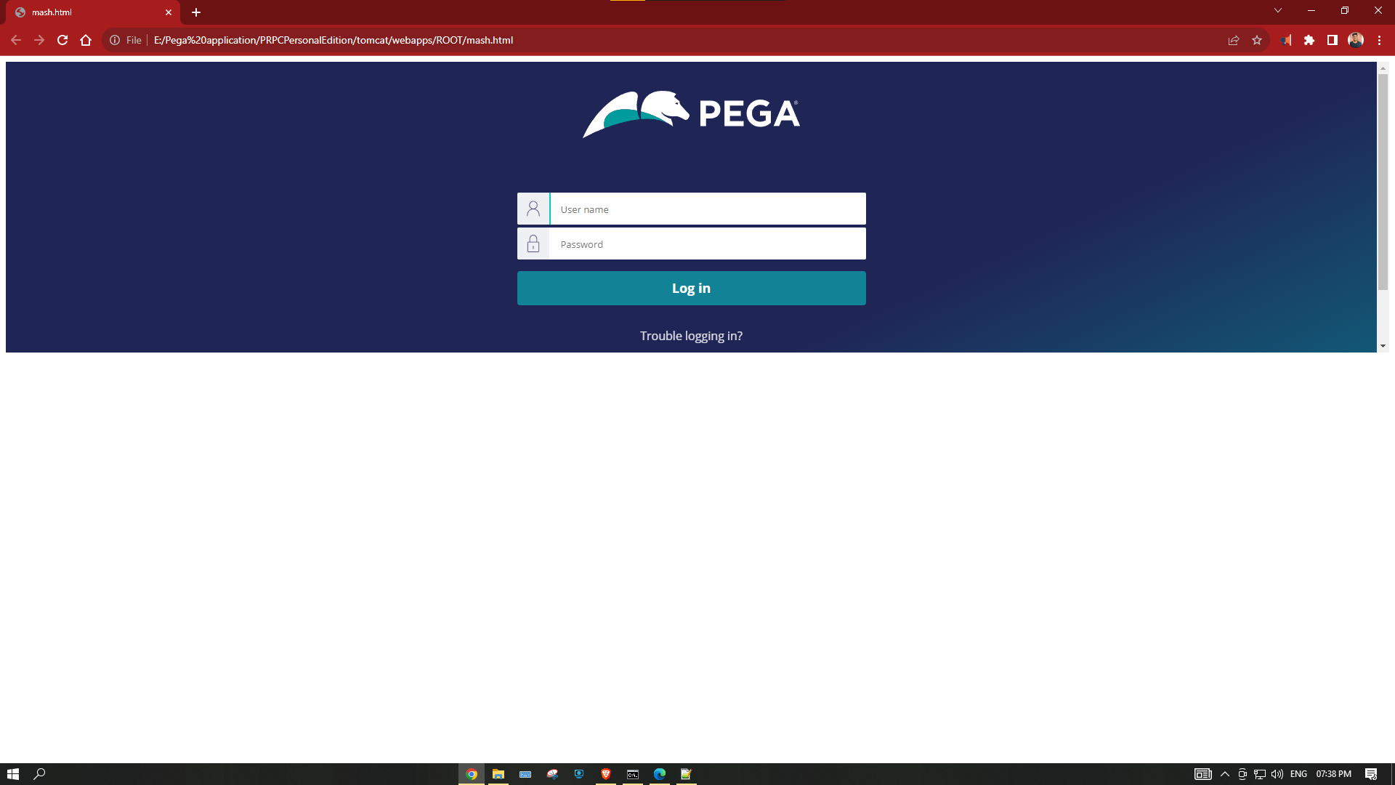

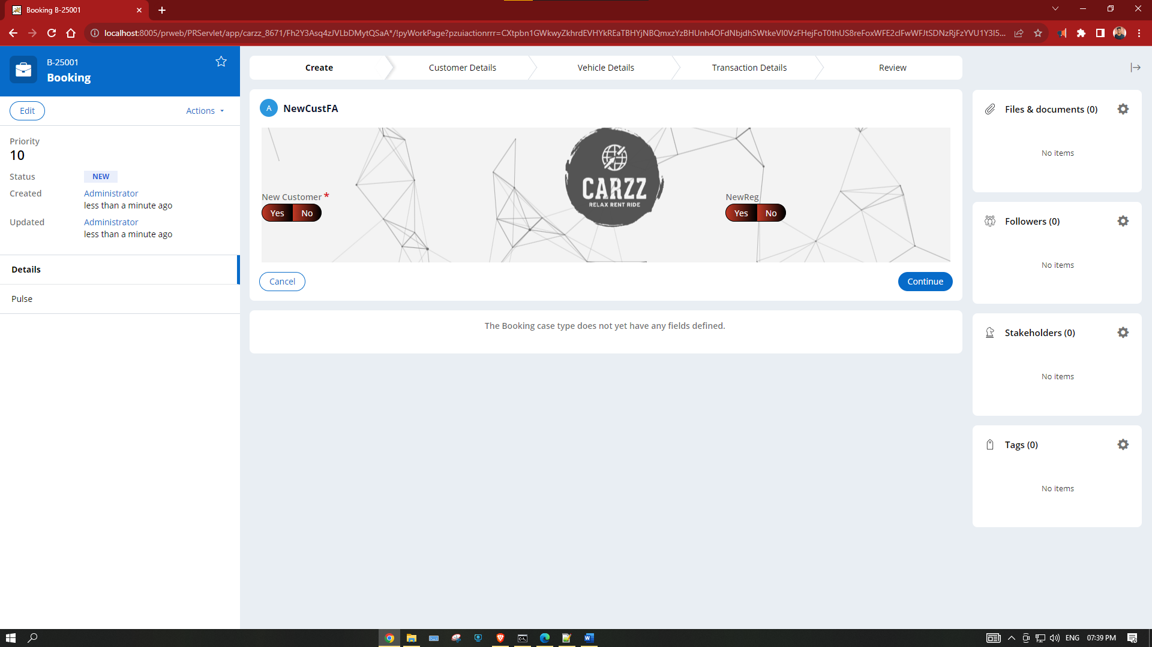

**5.4 Email listener:**

In Pega, an Email Listener is a powerful mechanism that allows the system to automatically process incoming emails. This feature is particularly useful for handling various business scenarios such as automatically creating cases, updating existing cases, or triggering specific actions based on the content of incoming emails.

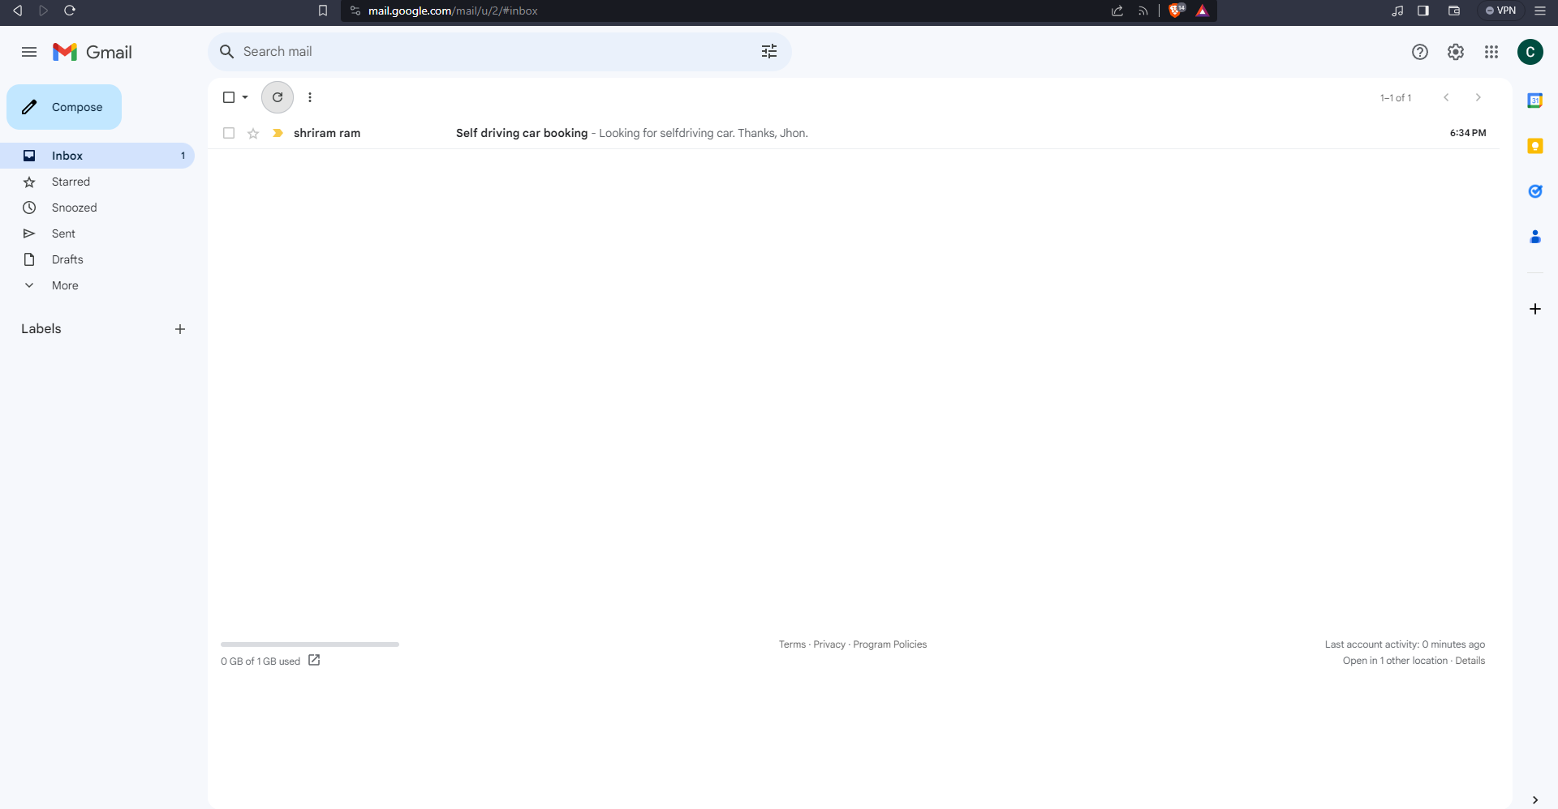

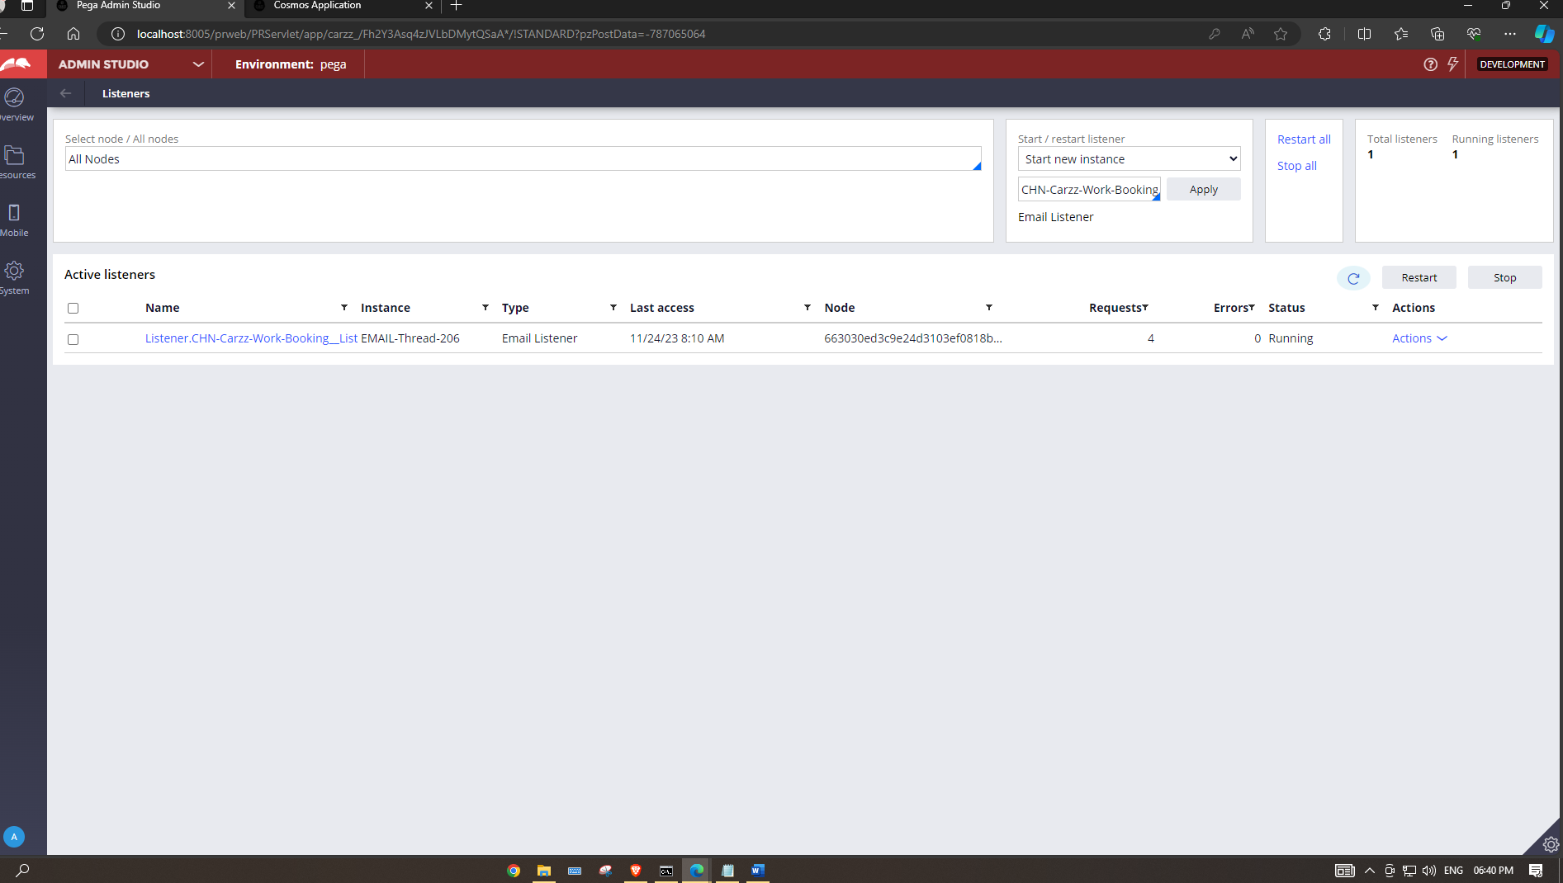

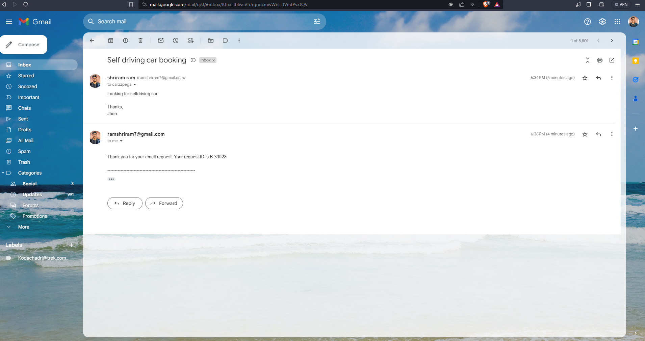

**5.5 Email Generation:**

In Pega, Email Generation is streamlined through Email Correspondence rules, allowing developers to design and automate the creation and delivery of emails within the application. Leveraging HTML or plain text, these rules enable dynamic inclusion of case-specific information and support the configuration of recipients, attachments, and links. Integrated seamlessly into workflows, Email Generation in Pega facilitates efficient communication by triggering personalized emails at key stages, enhancing user engagement and operational effectiveness.

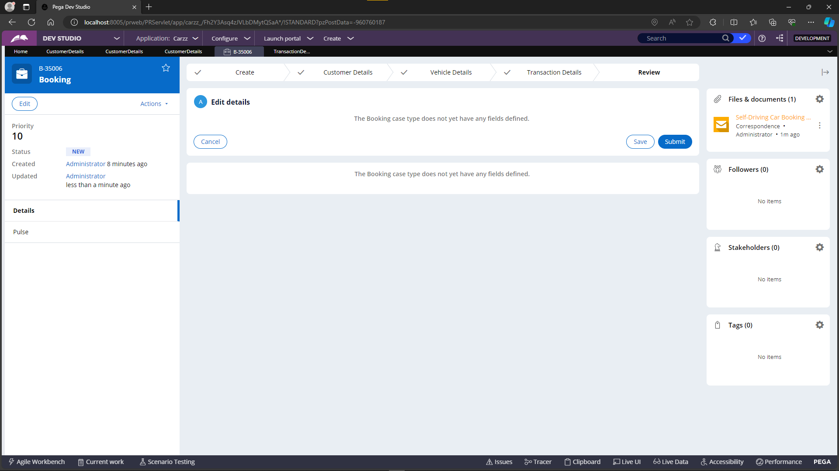

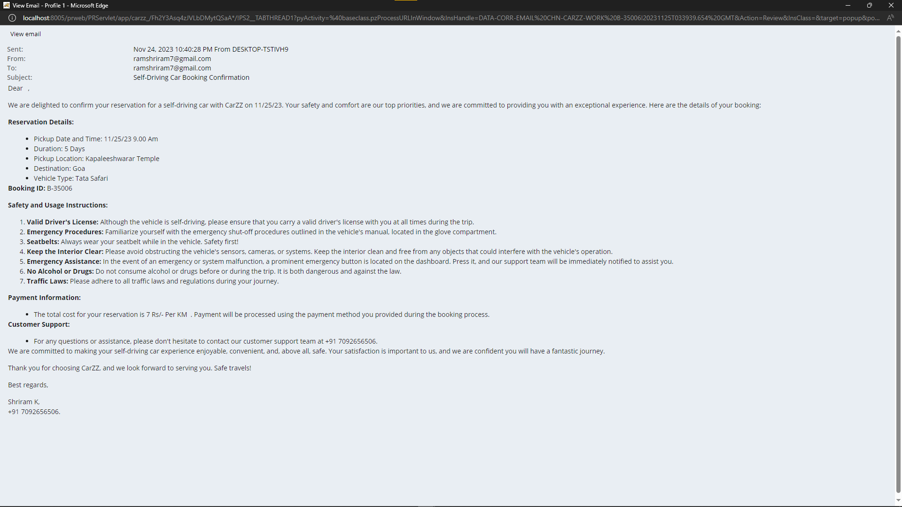

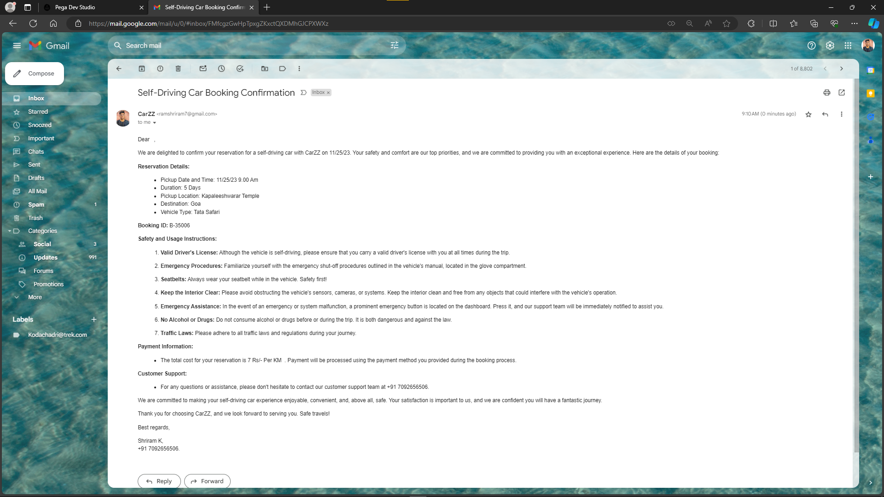

**5.6 Upload file:**

In Pega, the file upload functionality allows users to seamlessly attach and share documents within the application. This feature simplifies the process of submitting supporting materials, such as images, PDFs, or other file types, directly to the system. Users can conveniently upload files through designated interfaces, contributing to a more comprehensive and organized record-keeping system within the Pega application.

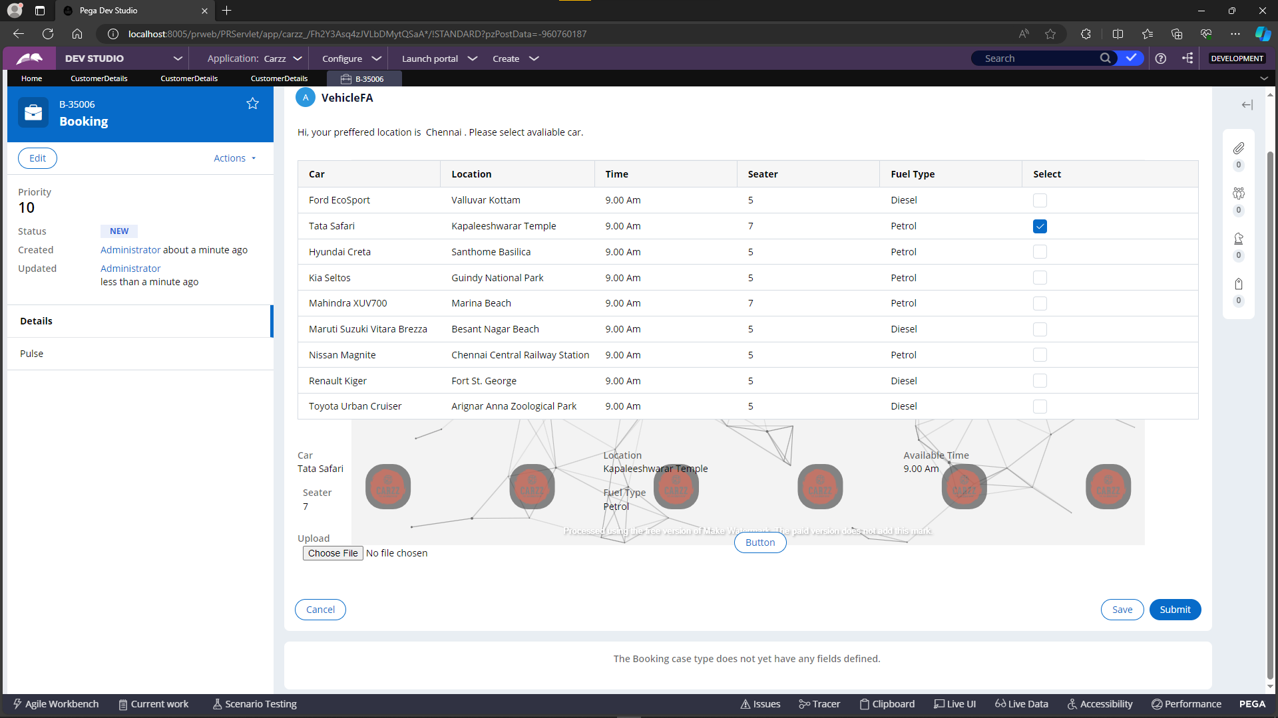

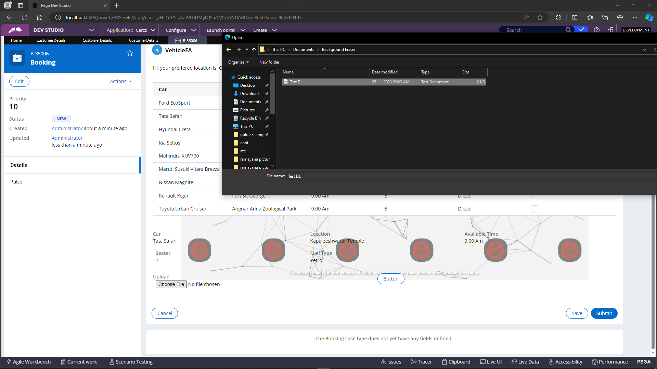

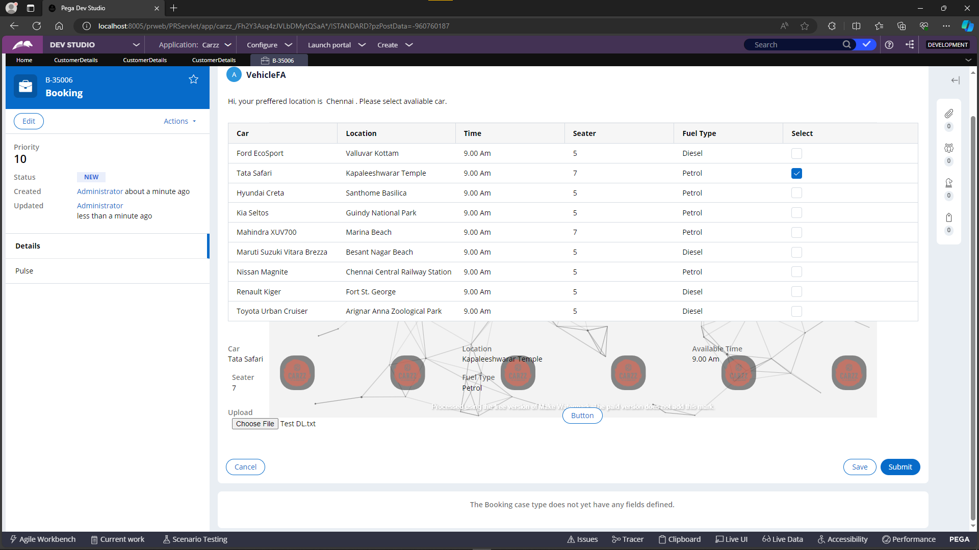

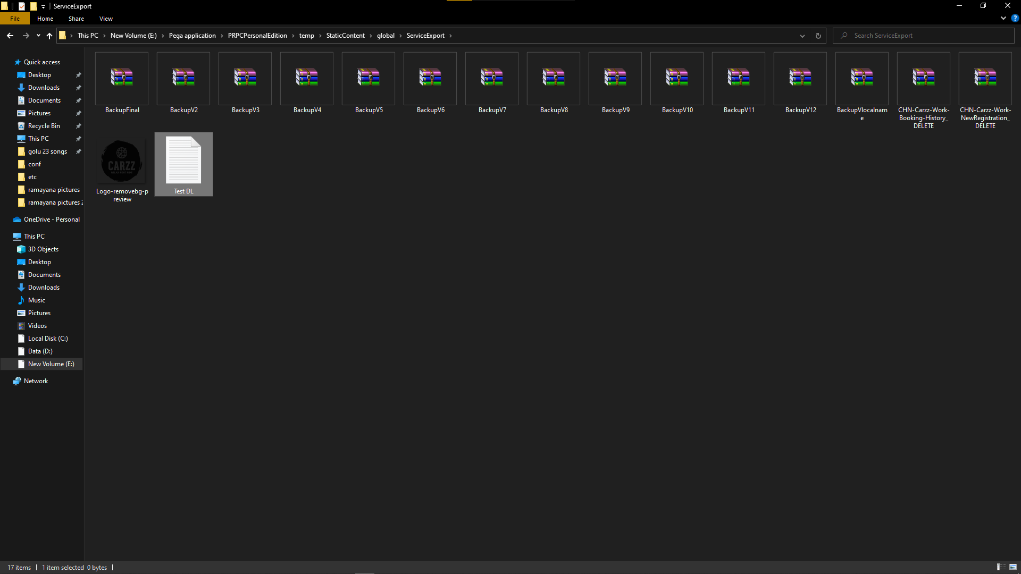

**6**. **End to end functionalities with screenshots**

**6.1** Booking case type

The application in built on Pega platform 8.7.

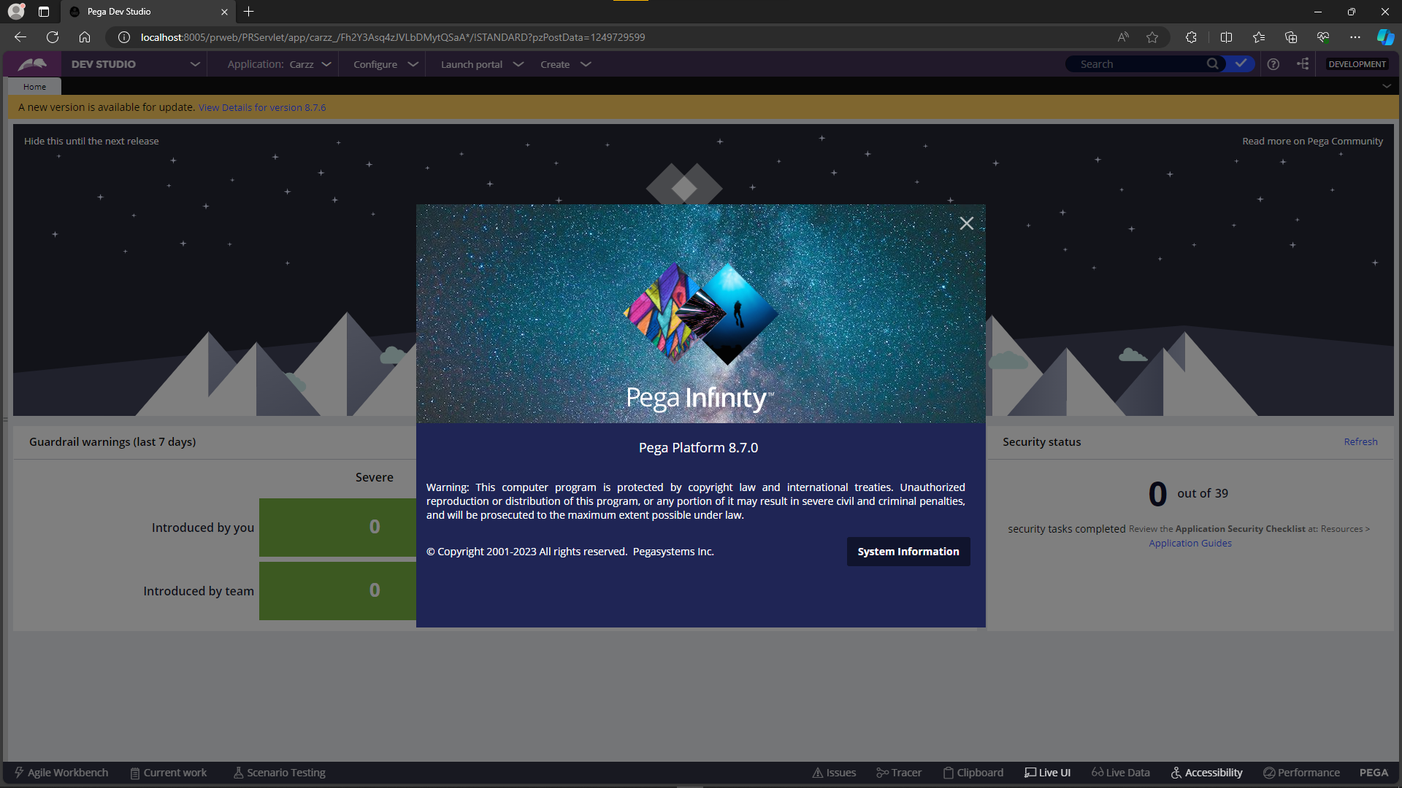

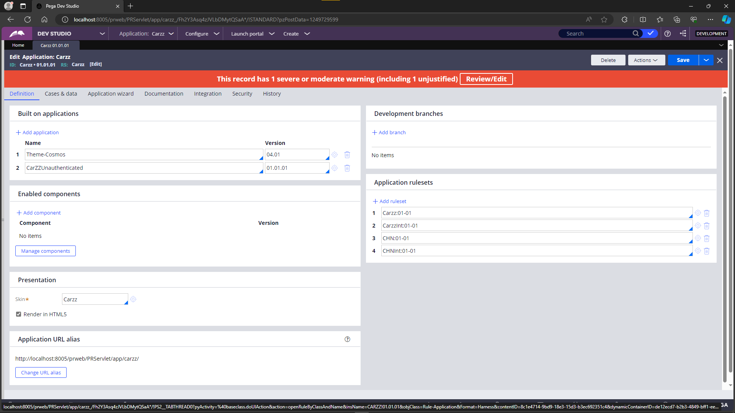

The landing page of the application features the company's icon and history, providing users with a visual introduction to the organization. The left panel has been customized using a harness rule to enhance the user interface. Additionally, a dynamic and engaging element is incorporated on the right half in the form of a banner, utilizing a GIF to add a visually appealing touch to the overall application experience.

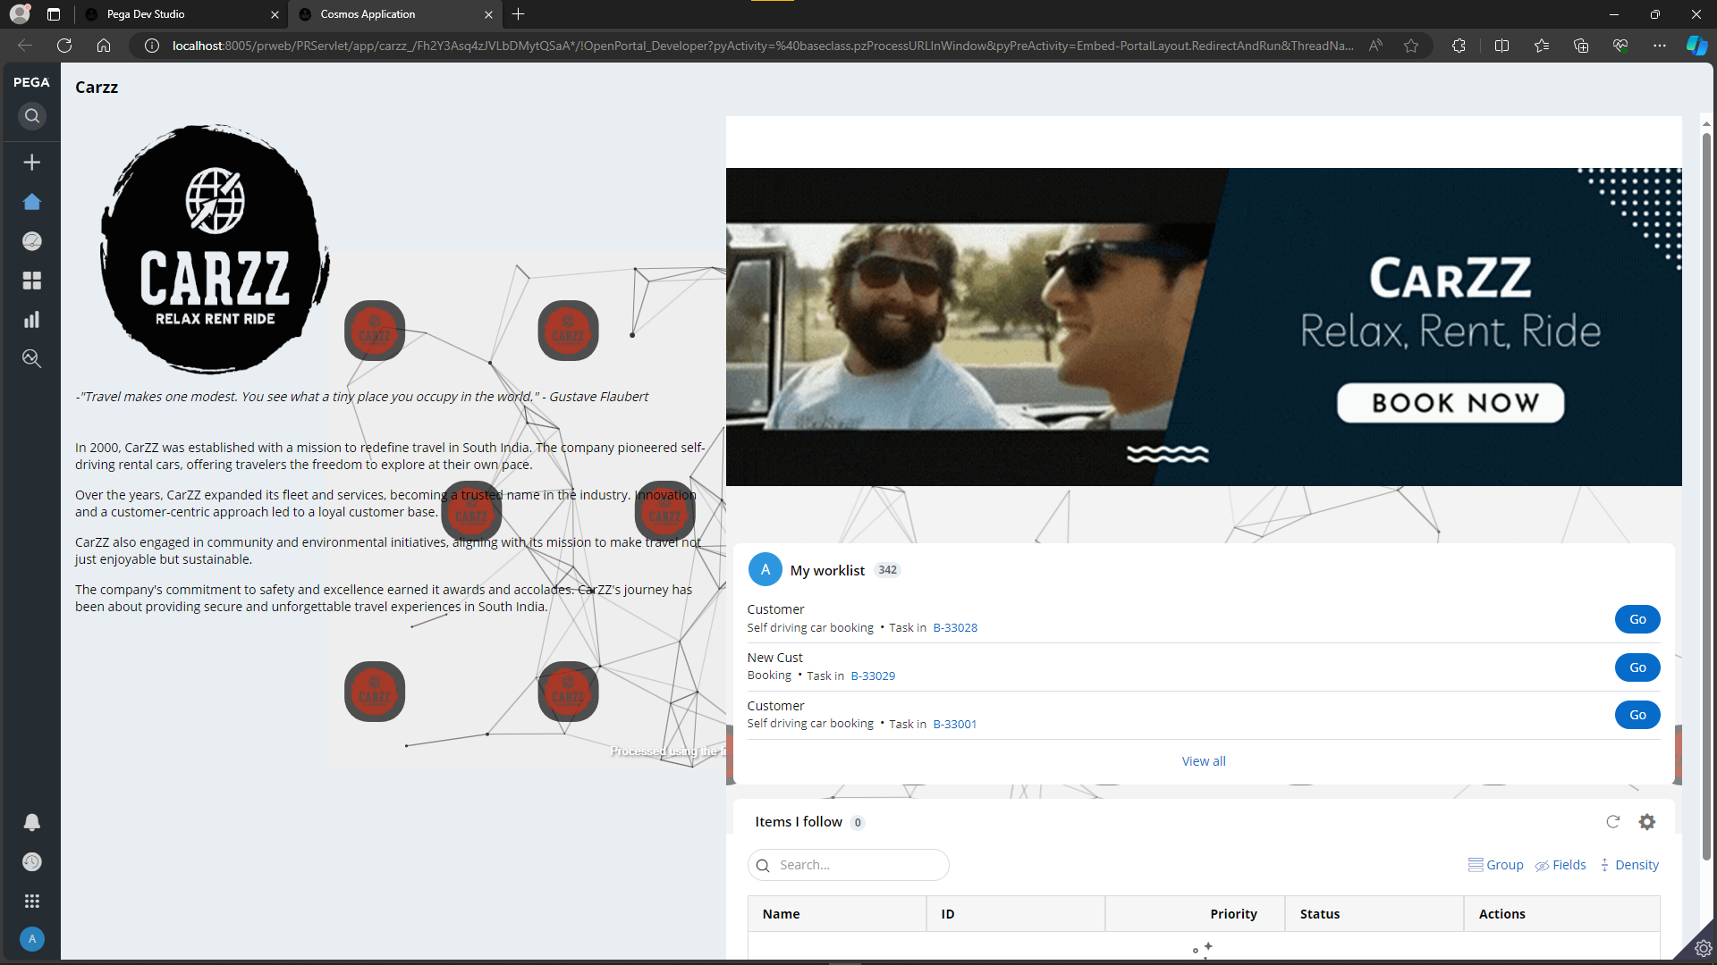

Upon selecting the "Booking" case type, the booking flow is initiated, offering users two distinct options: "New Customer" and "New Registration," each facilitated by radio button functionality. Subsequently, users can explore these flows individually, with the interface guiding them through the process step by step.

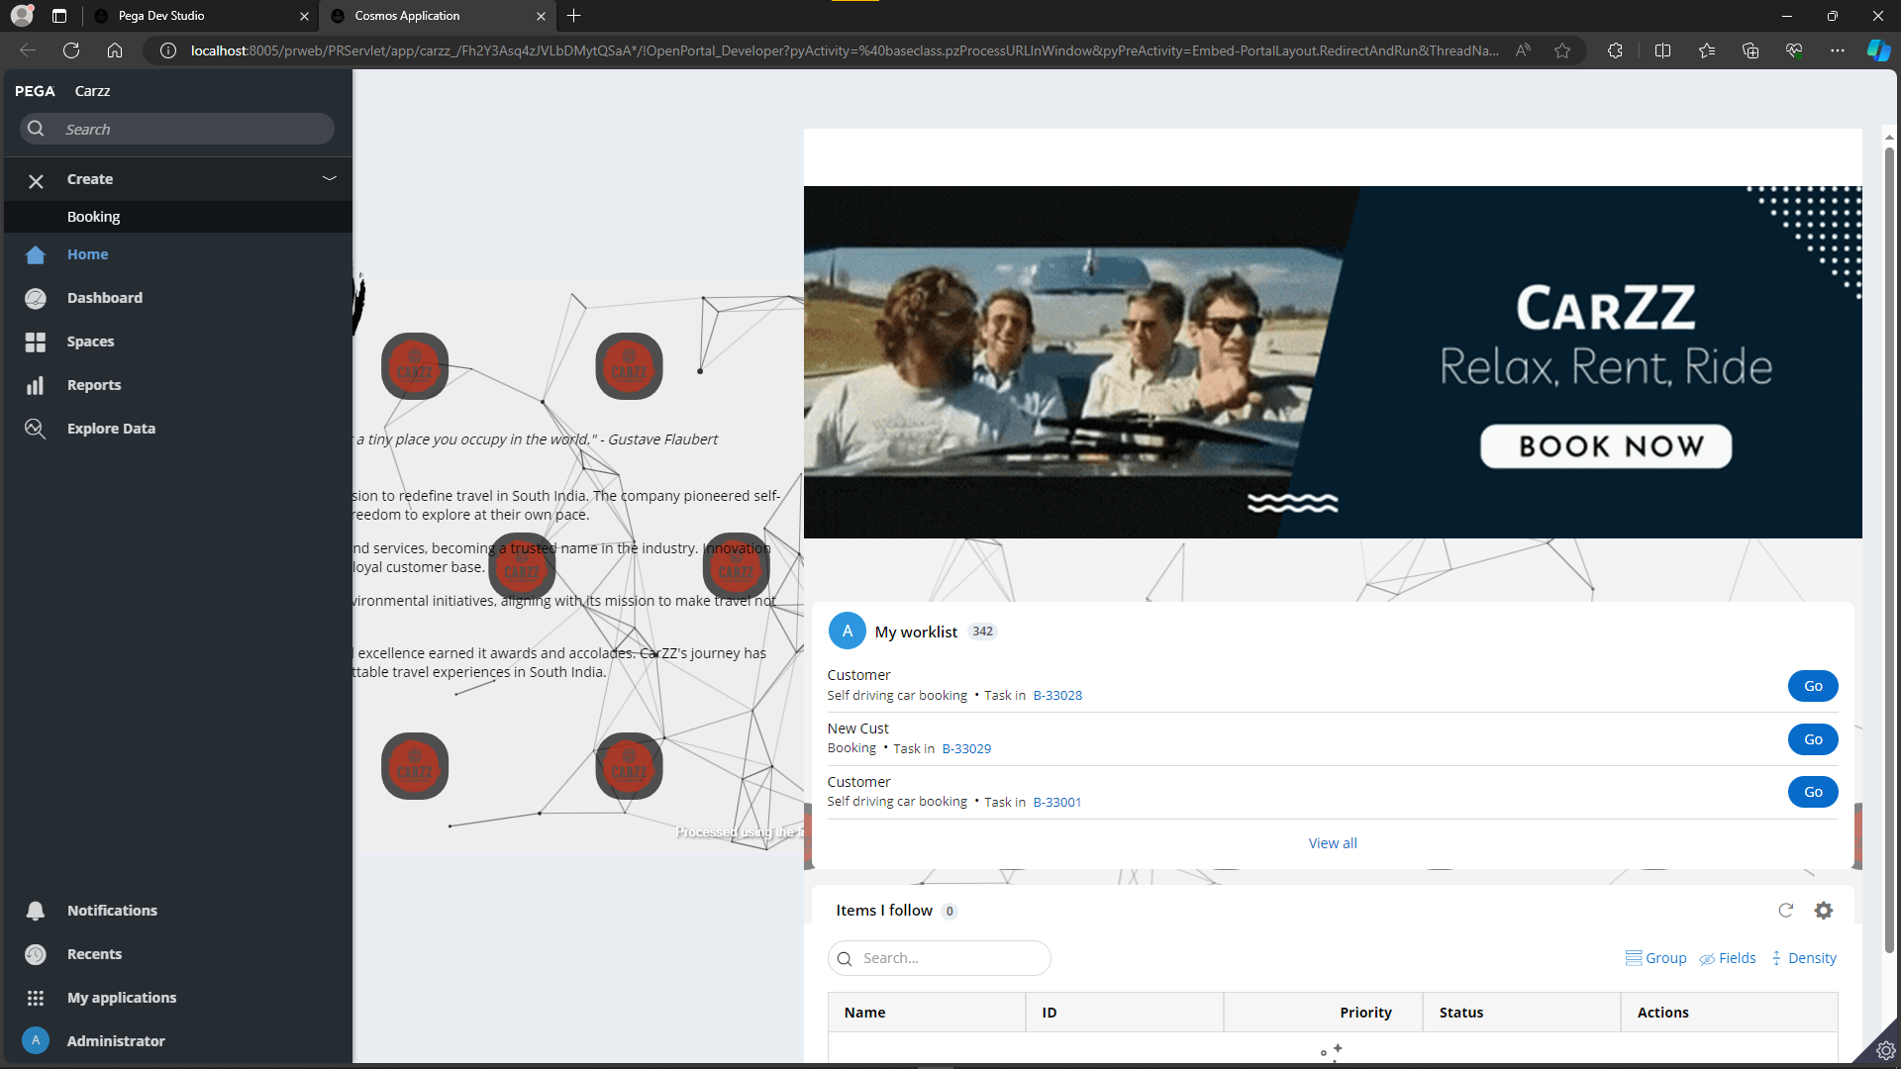

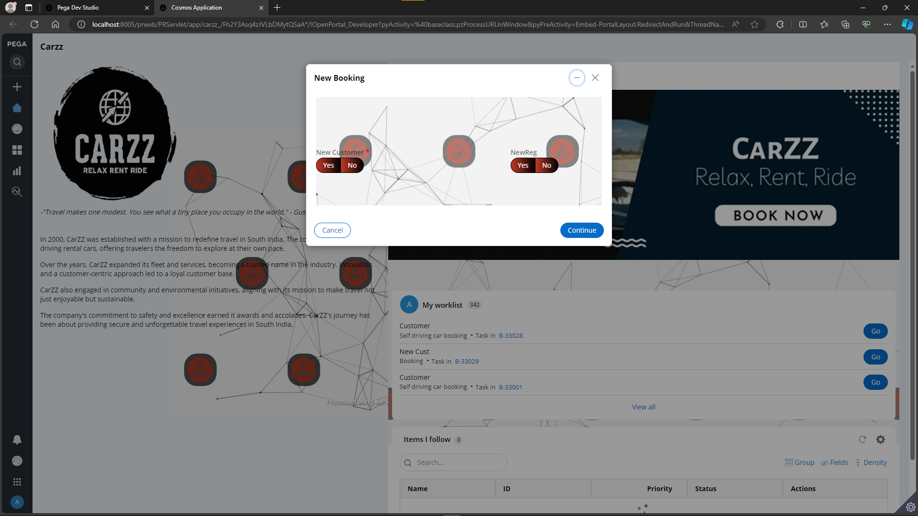

Upon selecting the "No" option for the "New Customer" radio button, a dropdown field dynamically appears based on visibility conditions. This dropdown field is populated with a list of customer IDs retrieved from the "customers" data type, providing users with a convenient selection mechanism within the application.

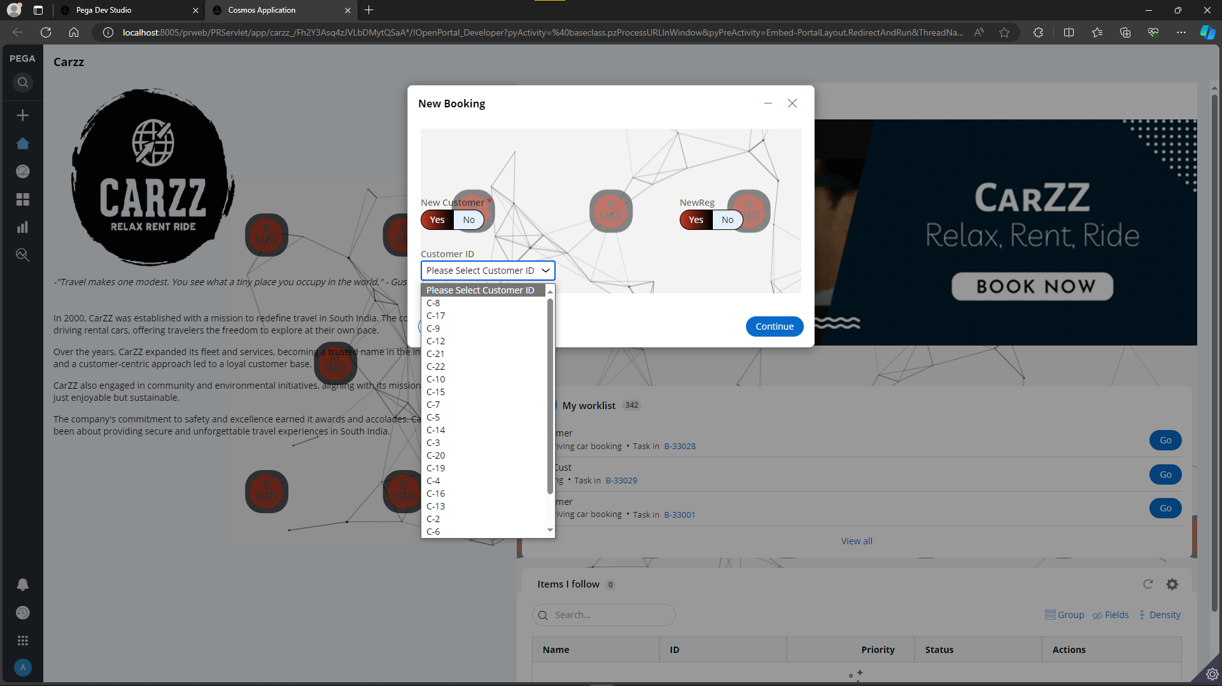

Upon selecting a specific customer, the subsequent screen reveals a form flow action. This form displays comprehensive details extracted from the customer data type, encompassing information such as the customer's first name, last name, mobile number, and email ID. Users can conveniently access and review these details within the application interface.

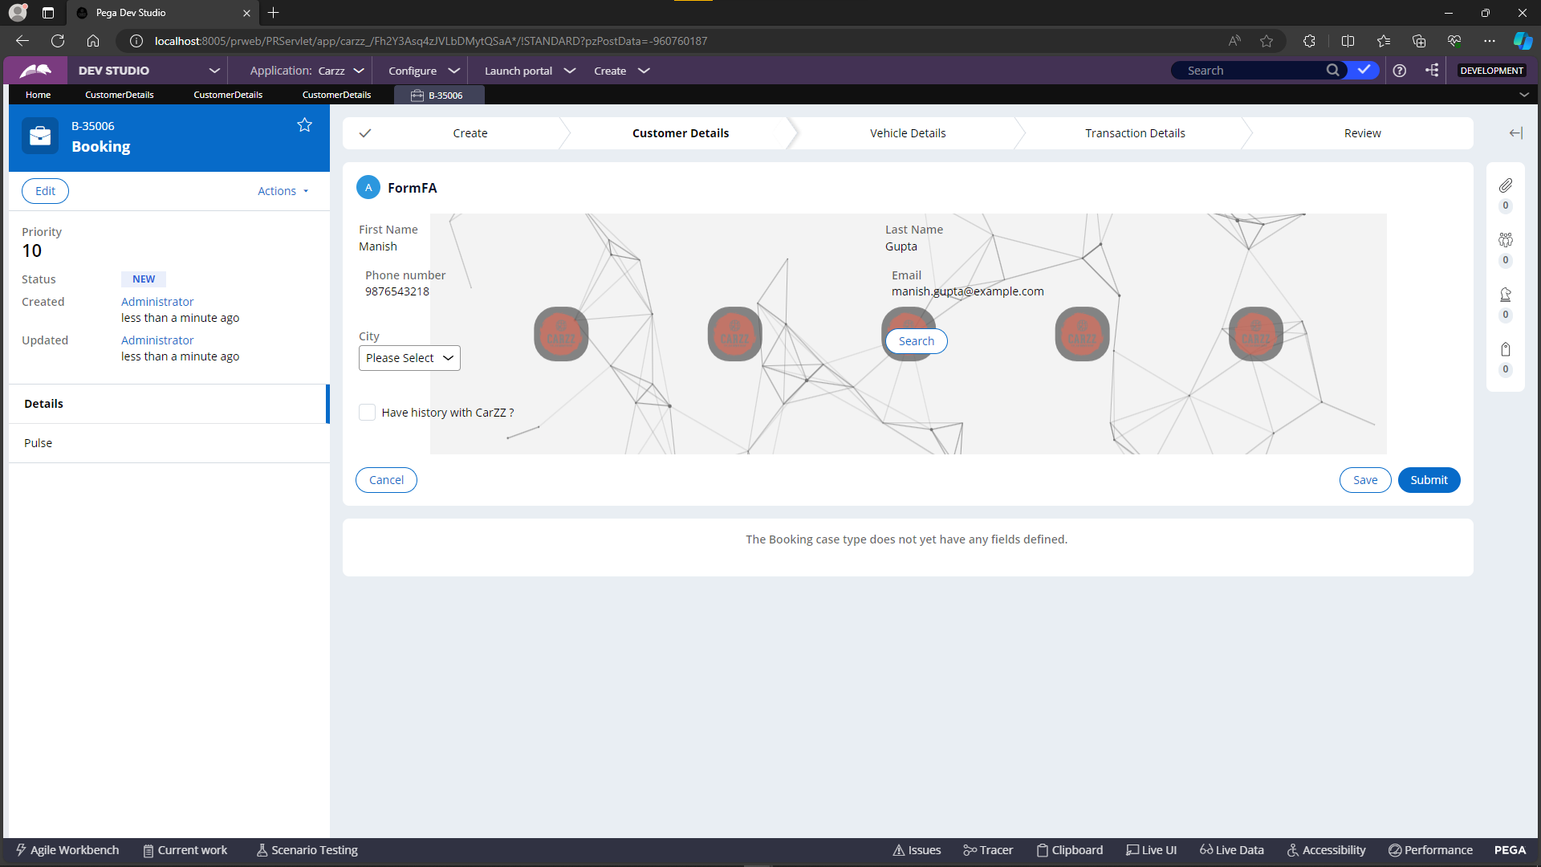

**New Customer Creation –**

In the subsequent flow, when opting for the creation of a new customer in the data type, both the "New Customer" and "New Registration" options should be set to "Yes." Following this selection, a new dialogue box prompts users to input essential details, including first name, last name, email ID, and phone number, facilitating the creation of a new customer record in the system.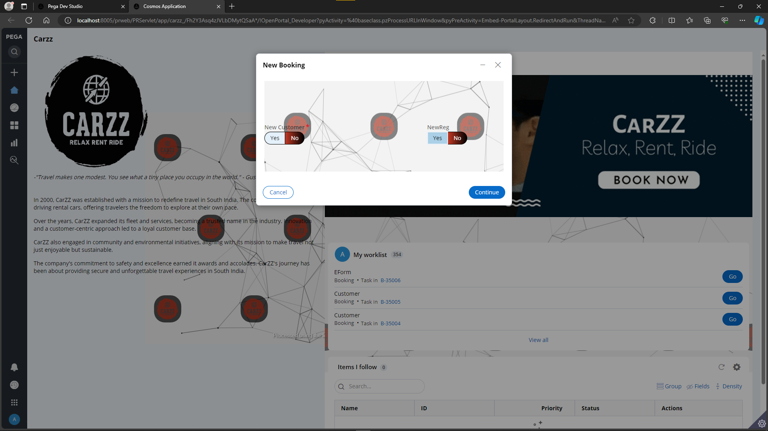

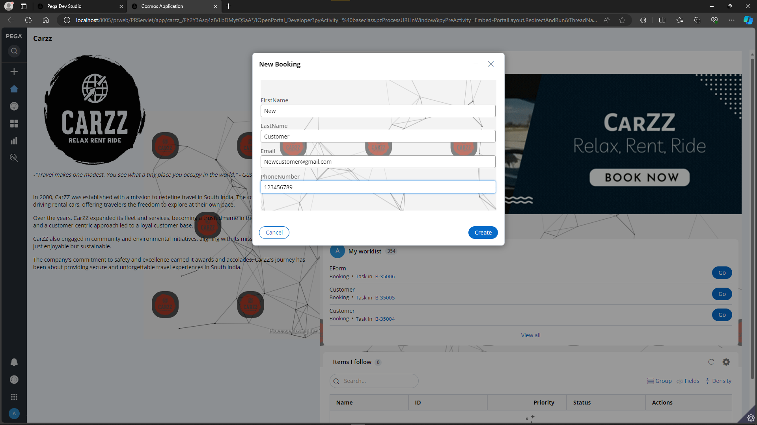

When the user clicks the "Create" button, an activity is initiated, capturing the previously filled details. The gathered information is then saved to the customer data type using the Obj-Save method. Subsequently, the application screen is updated to showcase a new customer ID alongside the details provided in the preceding screen, providing a seamless and transparent experience for users.

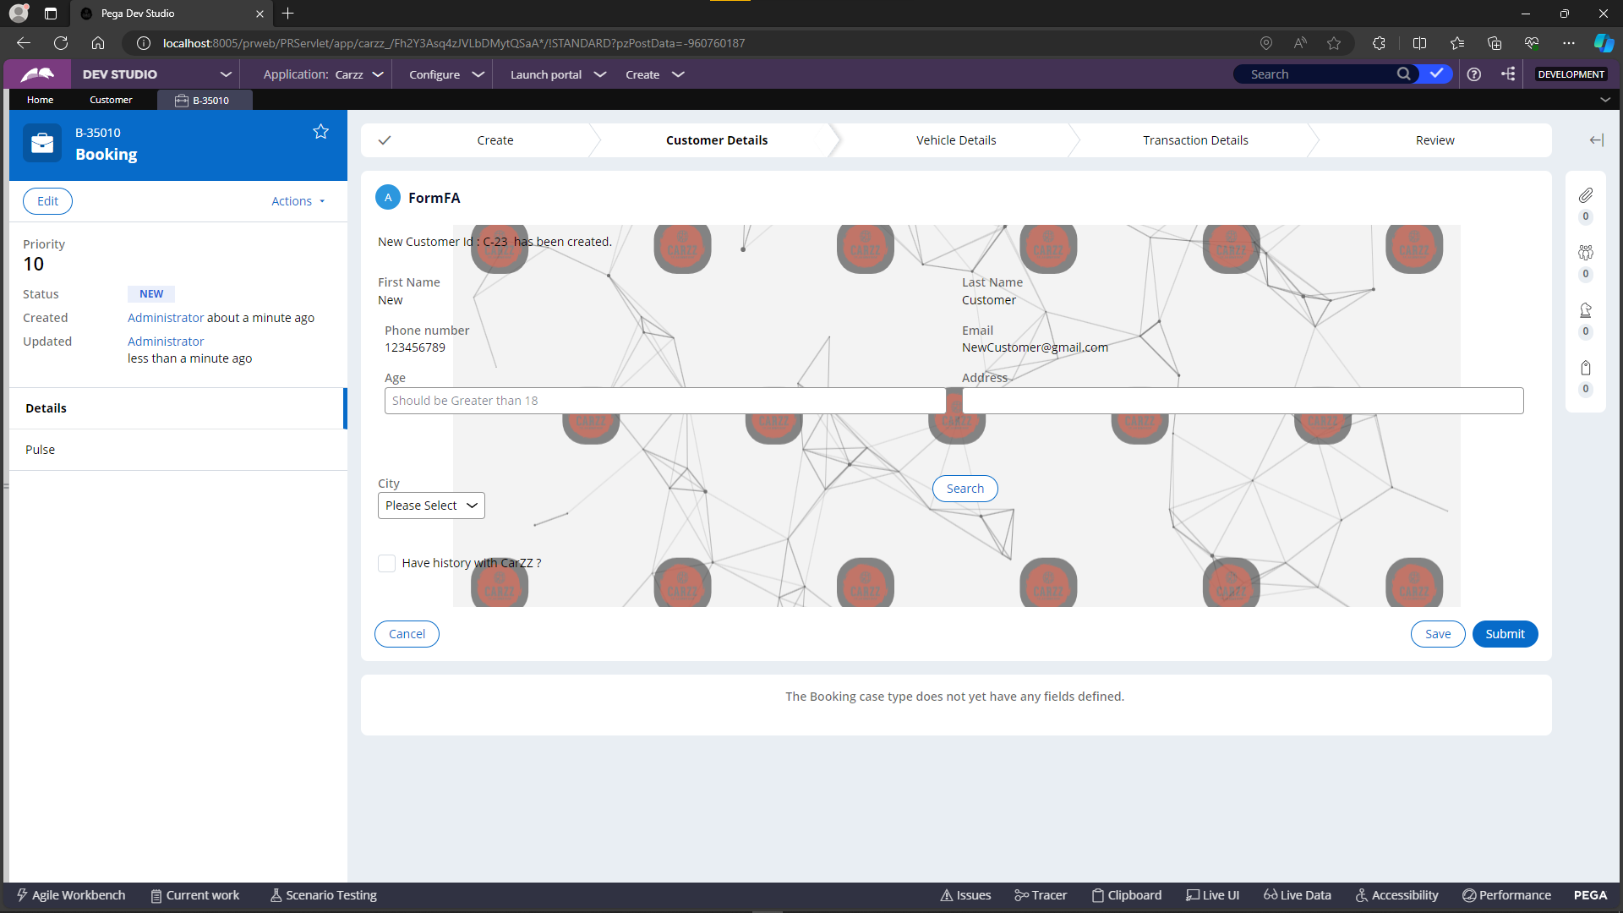

The below image holds the new customer creation and the ID value as C -23.

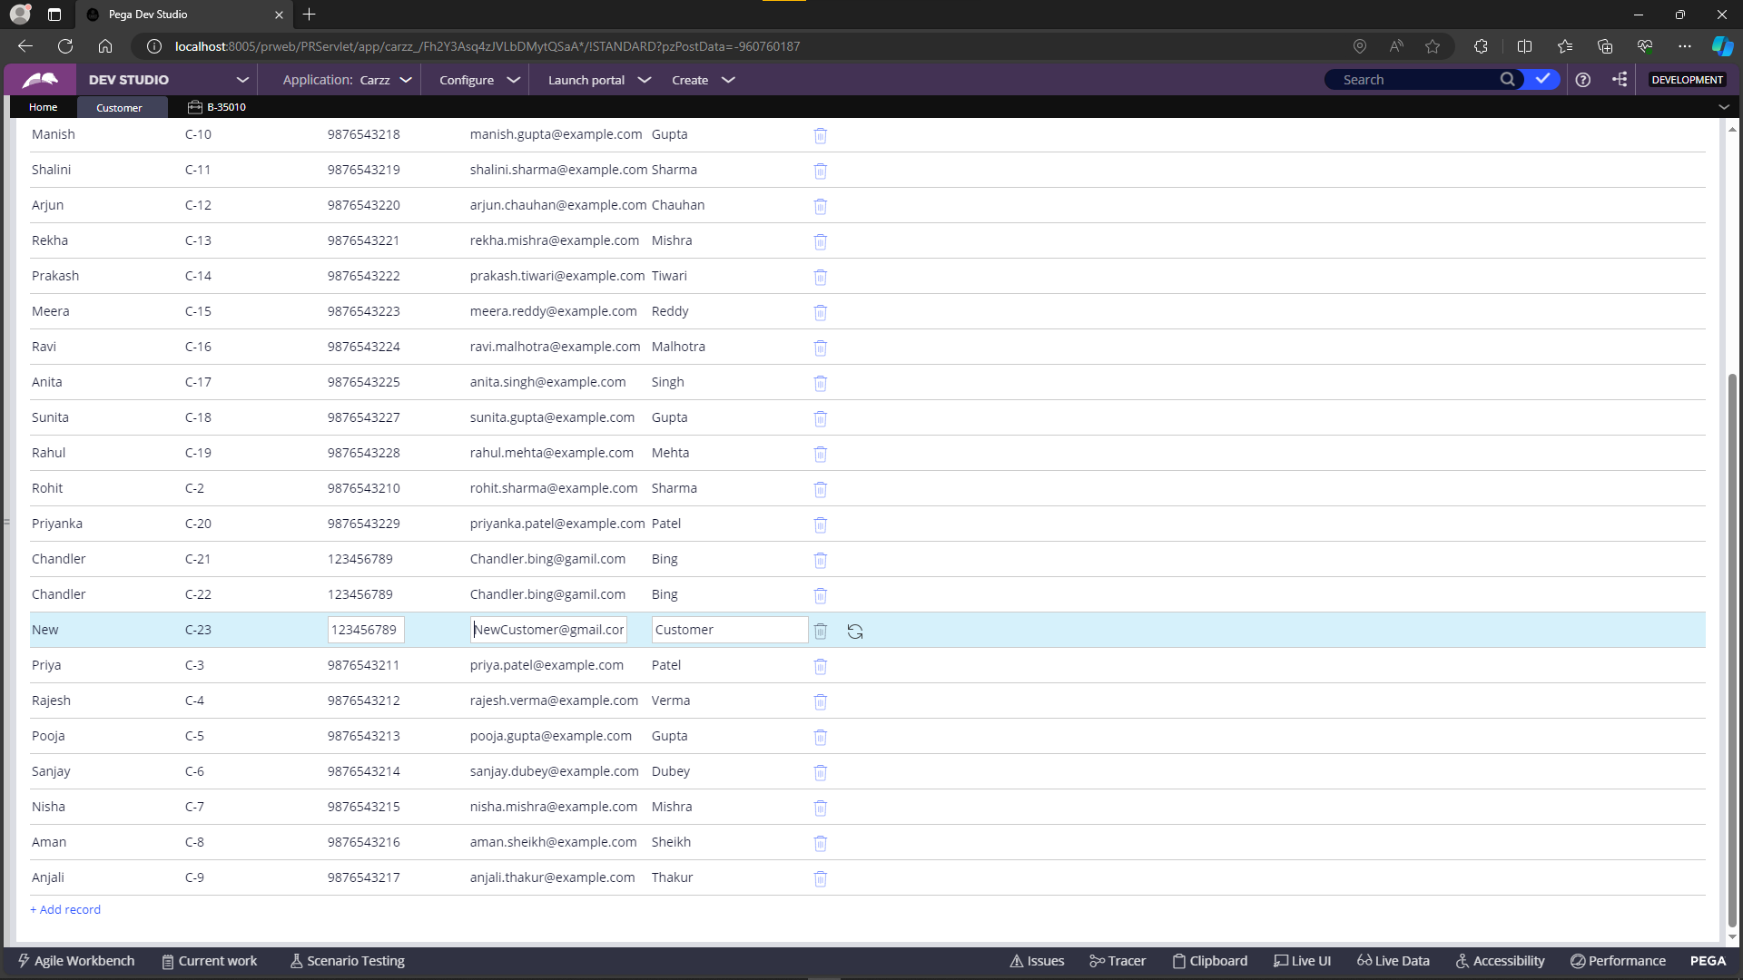

On an alternate path, users encounter a dropdown featuring a selection of cities, incorporated for practice purposes. The city names are sourced from a data type named "City," encompassing a curated list. Upon selecting a city from the dropdown and initiating a search, a table layout dynamically appears on the screen. This table displays relevant information, presenting the chosen city along with its associated pin code, offering users a comprehensive view of the selected location.

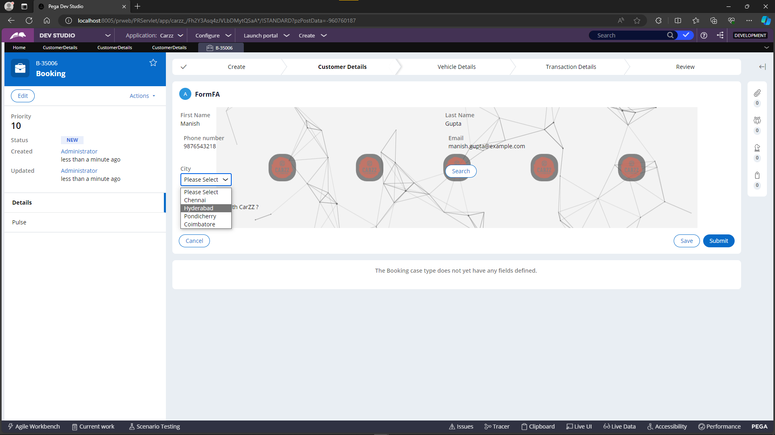

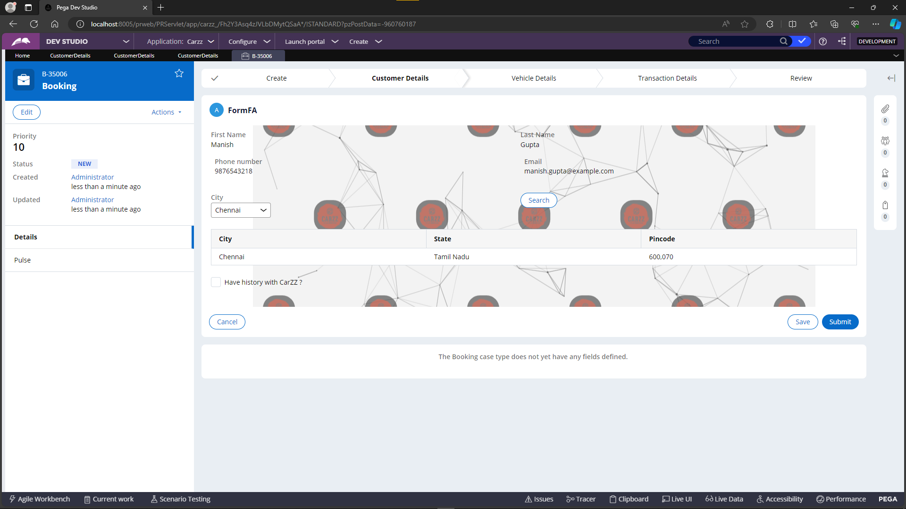

At the top of the screen, users will find the city name prominently displayed, indicating the currently selected city from the previous screen. Directly below, a table showcases the available vehicles specific to the chosen city. Users can conveniently review the list of cars in this table and select their preferred option to proceed with the booking process. This user-friendly layout ensures a seamless and intuitive experience for selecting and booking vehicles in the designated city.

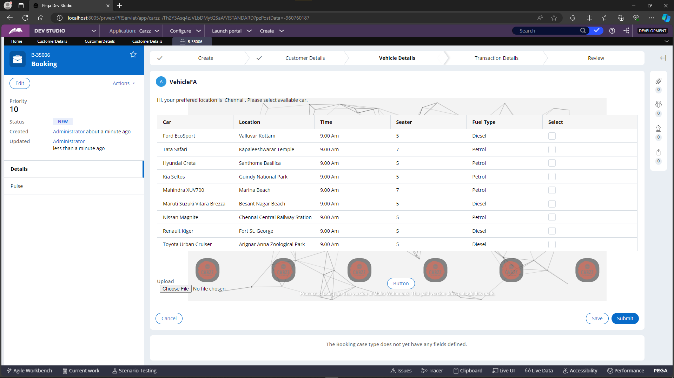



Upon selecting the checkbox associated with a specific car in the table, the details of the chosen vehicle dynamically appear below in a dedicated layout. This ensures users have comprehensive information about the selected car. Additionally, a file upload functionality is seamlessly integrated into the screen, allowing users to attach any pertinent documents related to the chosen vehicle. This feature enhances the overall versatility and documentation capabilities within the application.





After uploading a file, users can immediately view the file name, providing transparency in the process. Simultaneously, the application ensures that the file is successfully stored in the local storage, allowing users to confirm the upload and fostering a clear understanding of the document management within the system.



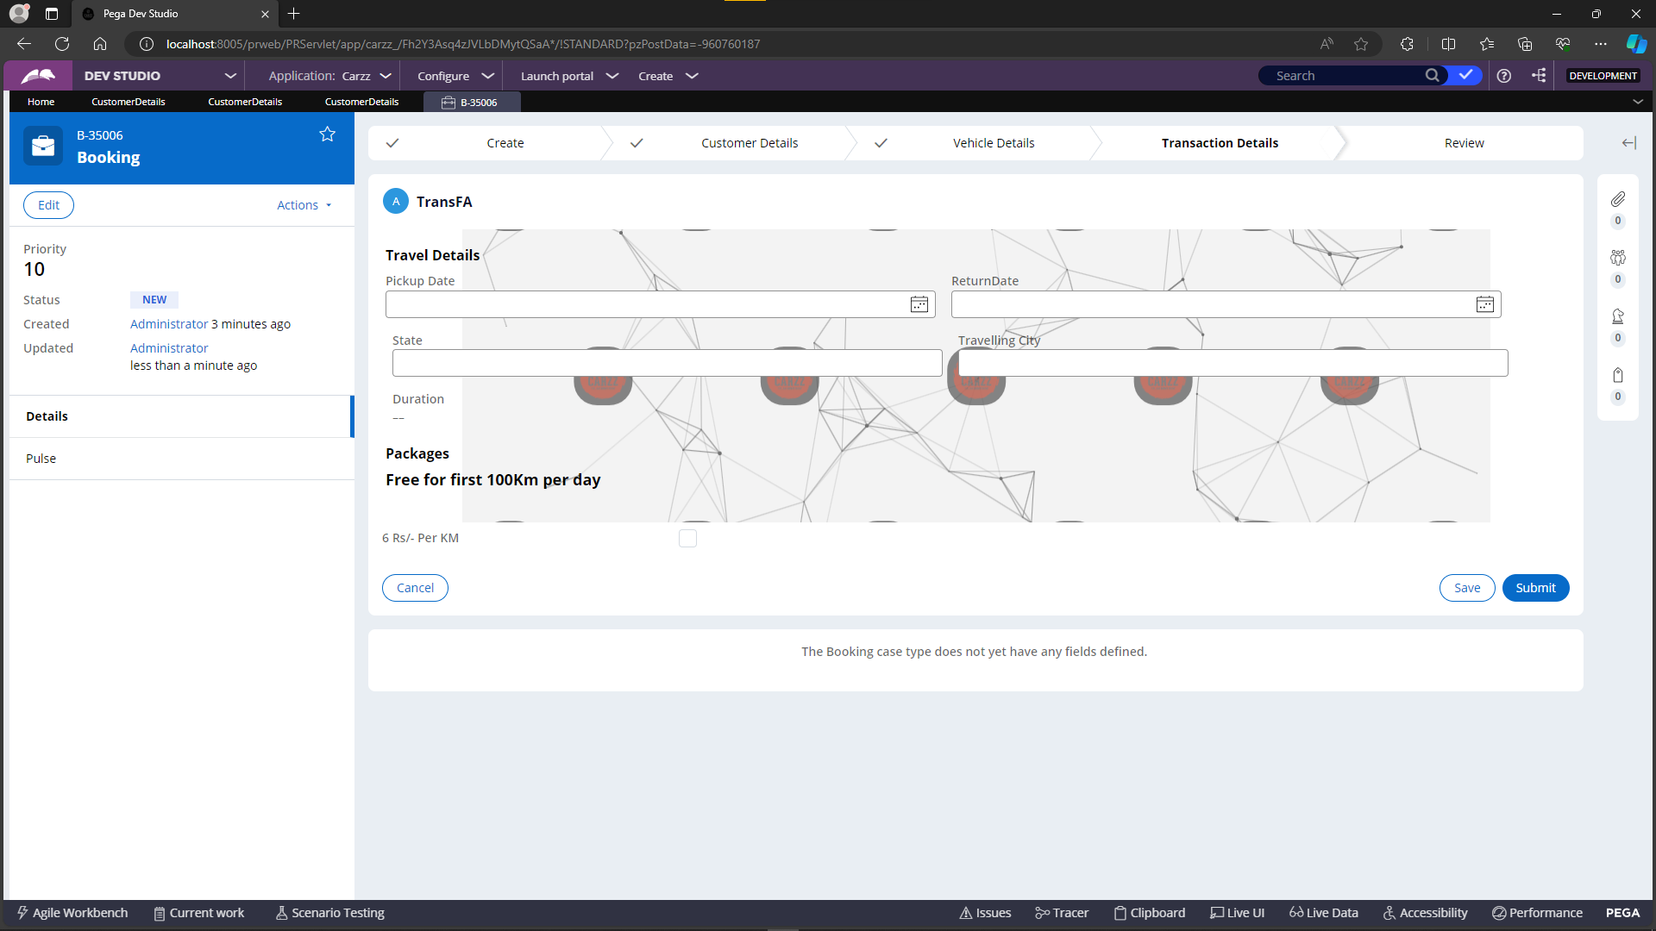

On the subsequent screen, users are prompted to input travel details, including the pickup date, destination city, and duration of the trip. The duration field is automatically calculated based on the difference between the pickup date and the current date, facilitated by the Declare OnChange rule.

Additionally, users encounter packages with associated checkboxes. Upon selecting specific checkboxes, an activity is triggered. This activity fetches details about the chosen vehicle, calculates the cost of the trip, and stores this information in a dedicated page. The accumulated data is then dynamically populated onto the review screen for user confirmation and verification.

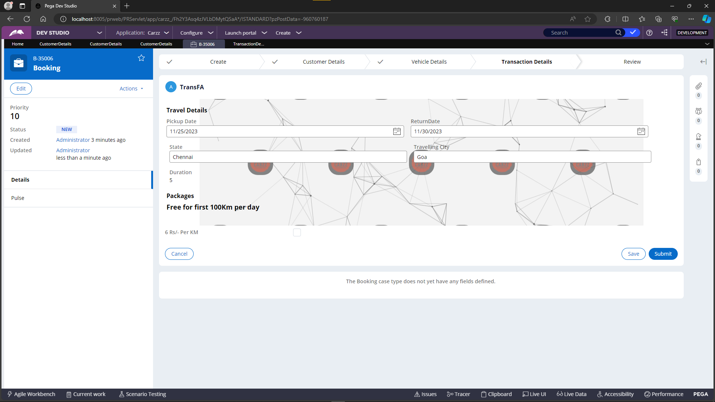

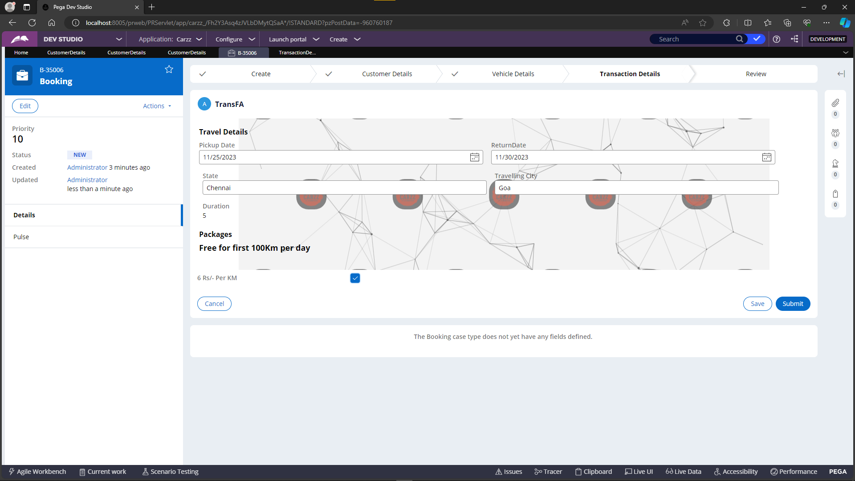

On the review screen, a notable feature includes the integration of Google Maps using OpenID functionality, leveraging the vehicle's location. This addition enhances the user experience by providing a visual representation of the selected vehicle's position, offering valuable context and geographical insight during the review process.



Upon clicking the "Submit" button on the review screen, an email is automatically triggered to the user's provided email address, which is sourced from the customer details page. This email contains comprehensive information, including details about the vehicle's location and other pertinent application specifics. This streamlined process ensures that users receive a confirmation email with essential details following the successful submission of their booking.







**6.2 History case type**

Now, let's explore the child case type initiated from the parent case. In this process, the flow begins with the selection of a customer ID within the parent case. On the subsequent form flow action screen, users encounter an option that pertains to the customer's history with the Cars application. This option allows users to access and review information related to a customer's past interactions and engagements with the application's features and services.

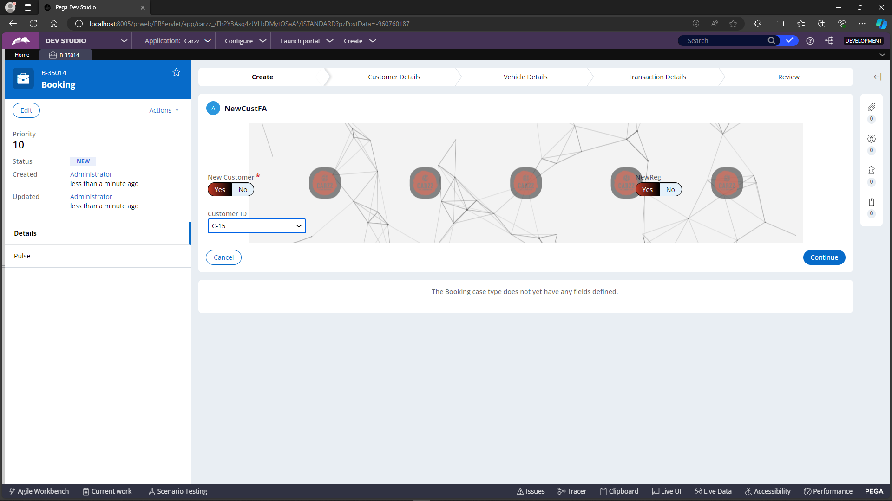

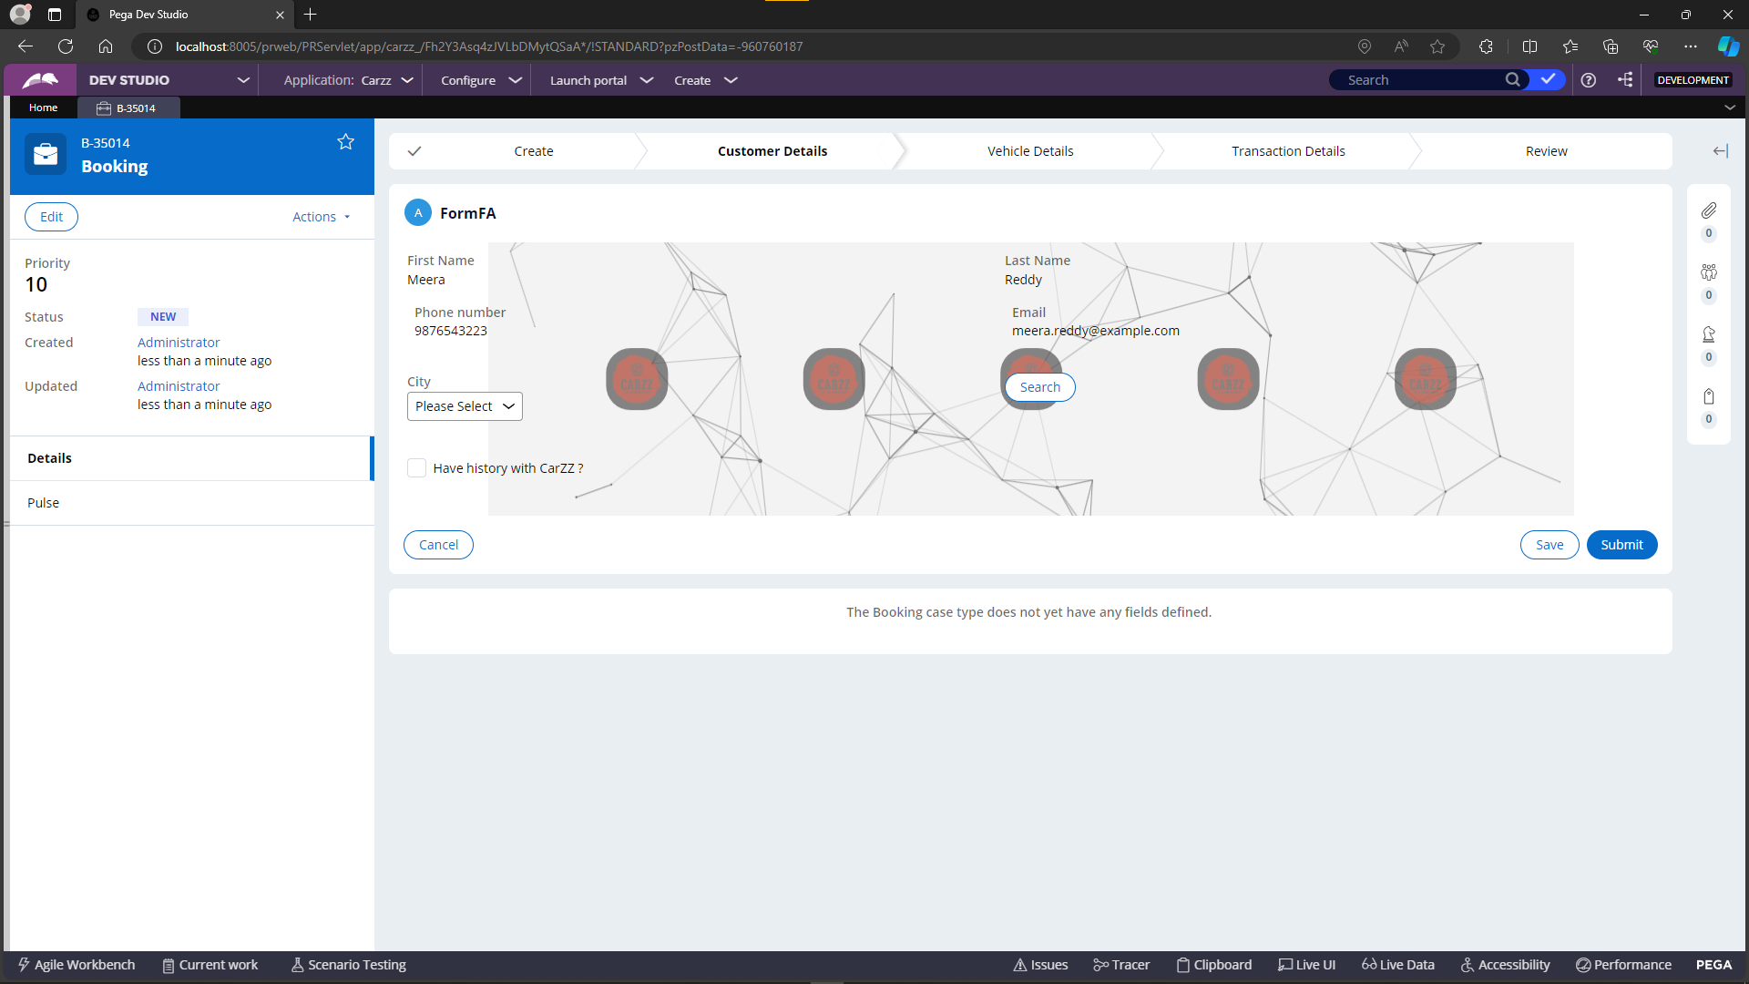

Upon selecting the checkbox indicating the customer's history with the Cars application, a new screen emerges, displaying a detailed history of vehicles they have preferred on their previous trips. Below this history, a convenient "Export to Excel" functionality has been integrated. Users can utilize this feature to export the displayed vehicle information in the table to an Excel sheet, facilitating easy access to and storage of their past vehicle preferences. The exported Excel file can then be downloaded for further reference.

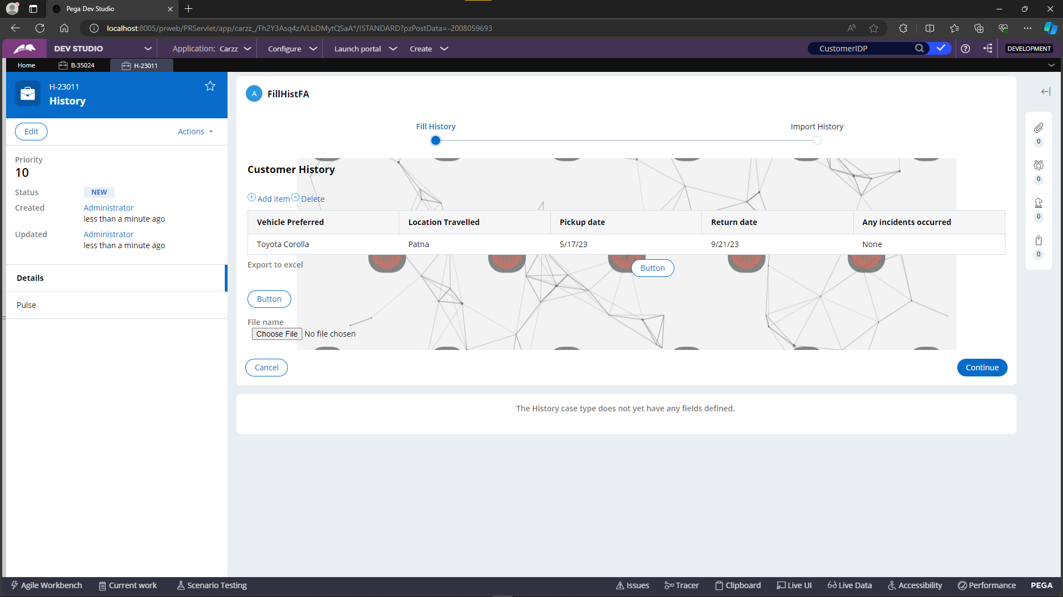

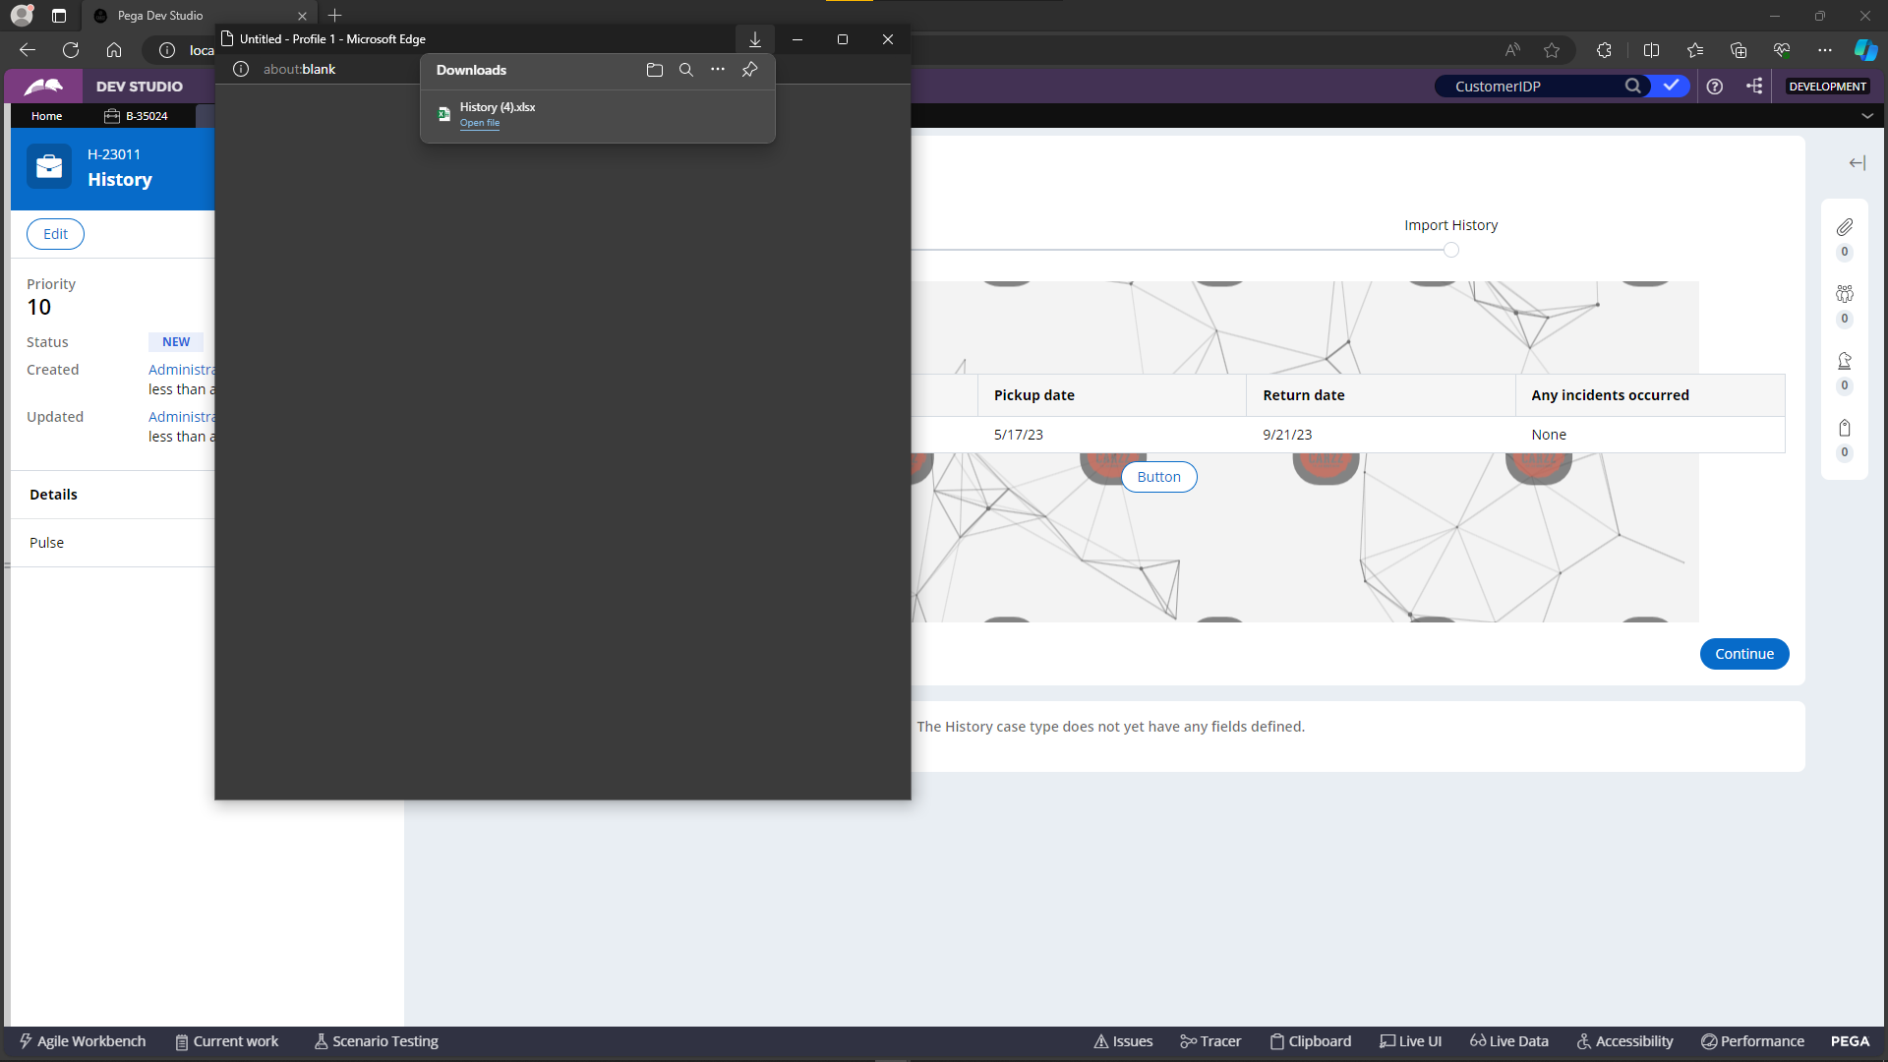



The "Attach File to a Case" functionality has been seamlessly incorporated below, allowing users to upload relevant files and associate them with the current case. As part of future enhancements, there are plans to implement a parsing mechanism for the attached sheets. This will involve extracting data from the attached sheets and presenting it in a structured format on a table, contributing to a more comprehensive and data-driven user experience within the application.

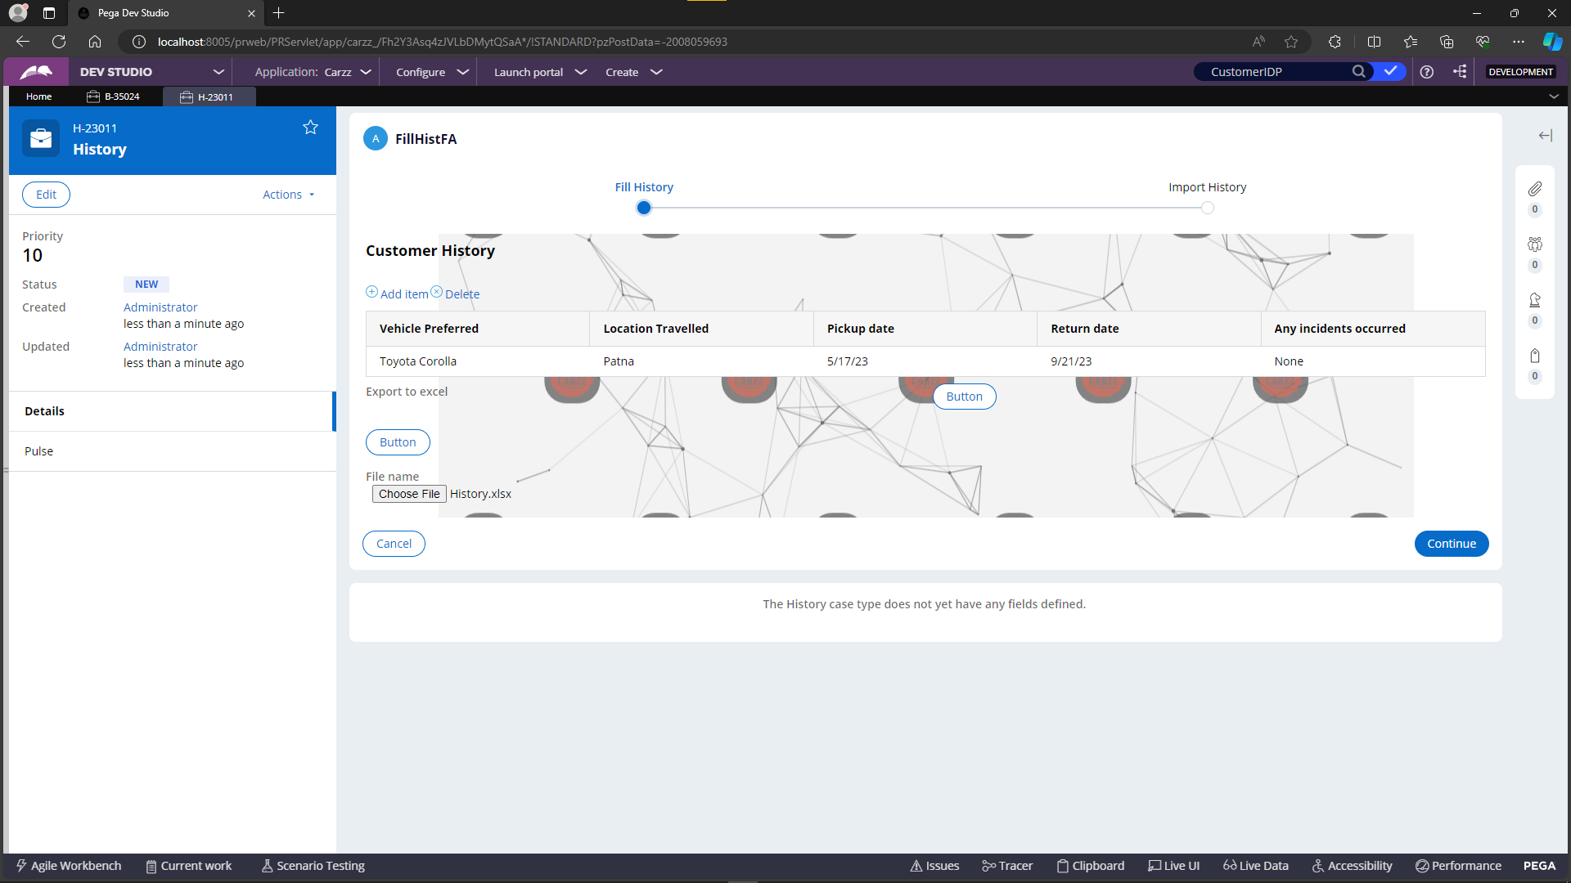

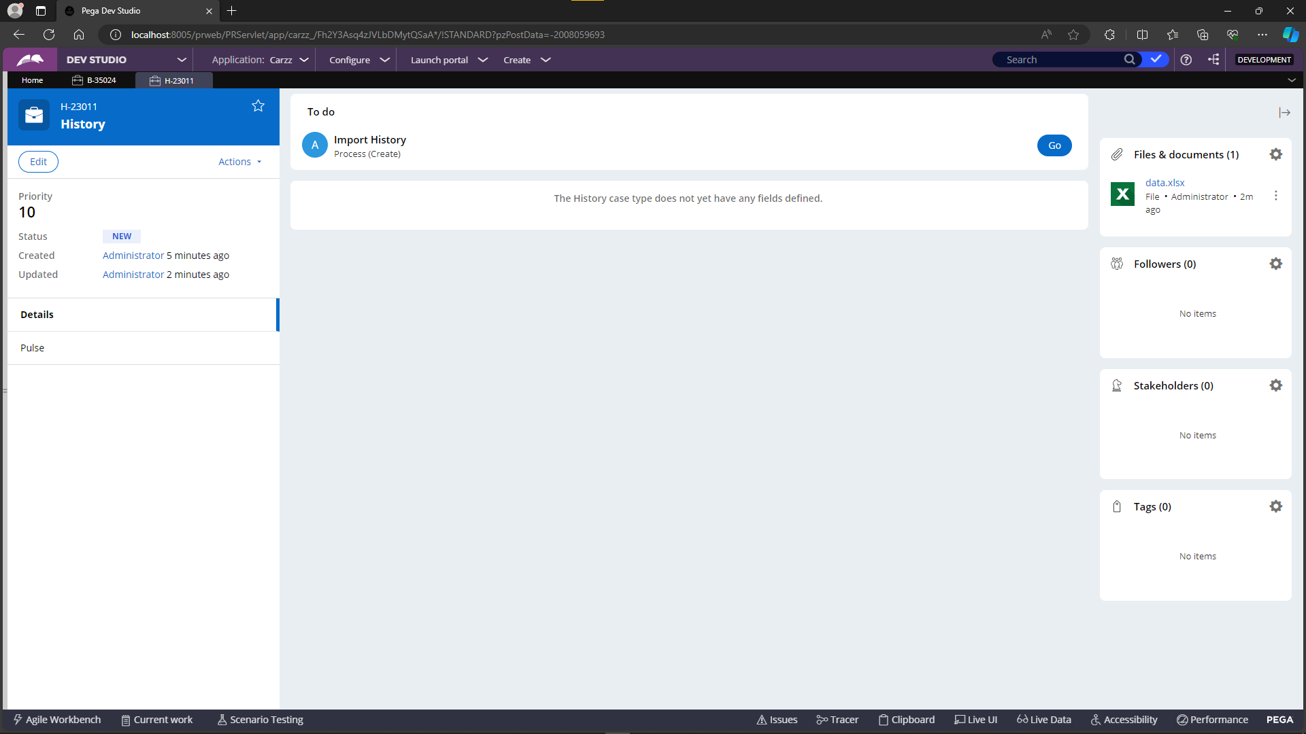

On the following screen, users can access predefined forms presented as paragraph rules. These forms are displayed in a table format, and users can select the desired form using checkboxes. By clicking the "Preview Form" button, a dialogue box appears, showcasing the selected form. Furthermore, users can click the "Print Selected Form" button to directly print the form. In future iterations, the plan is to integrate customer details into these forms, generate them as PDFs, and allow users to download the finalized documents.

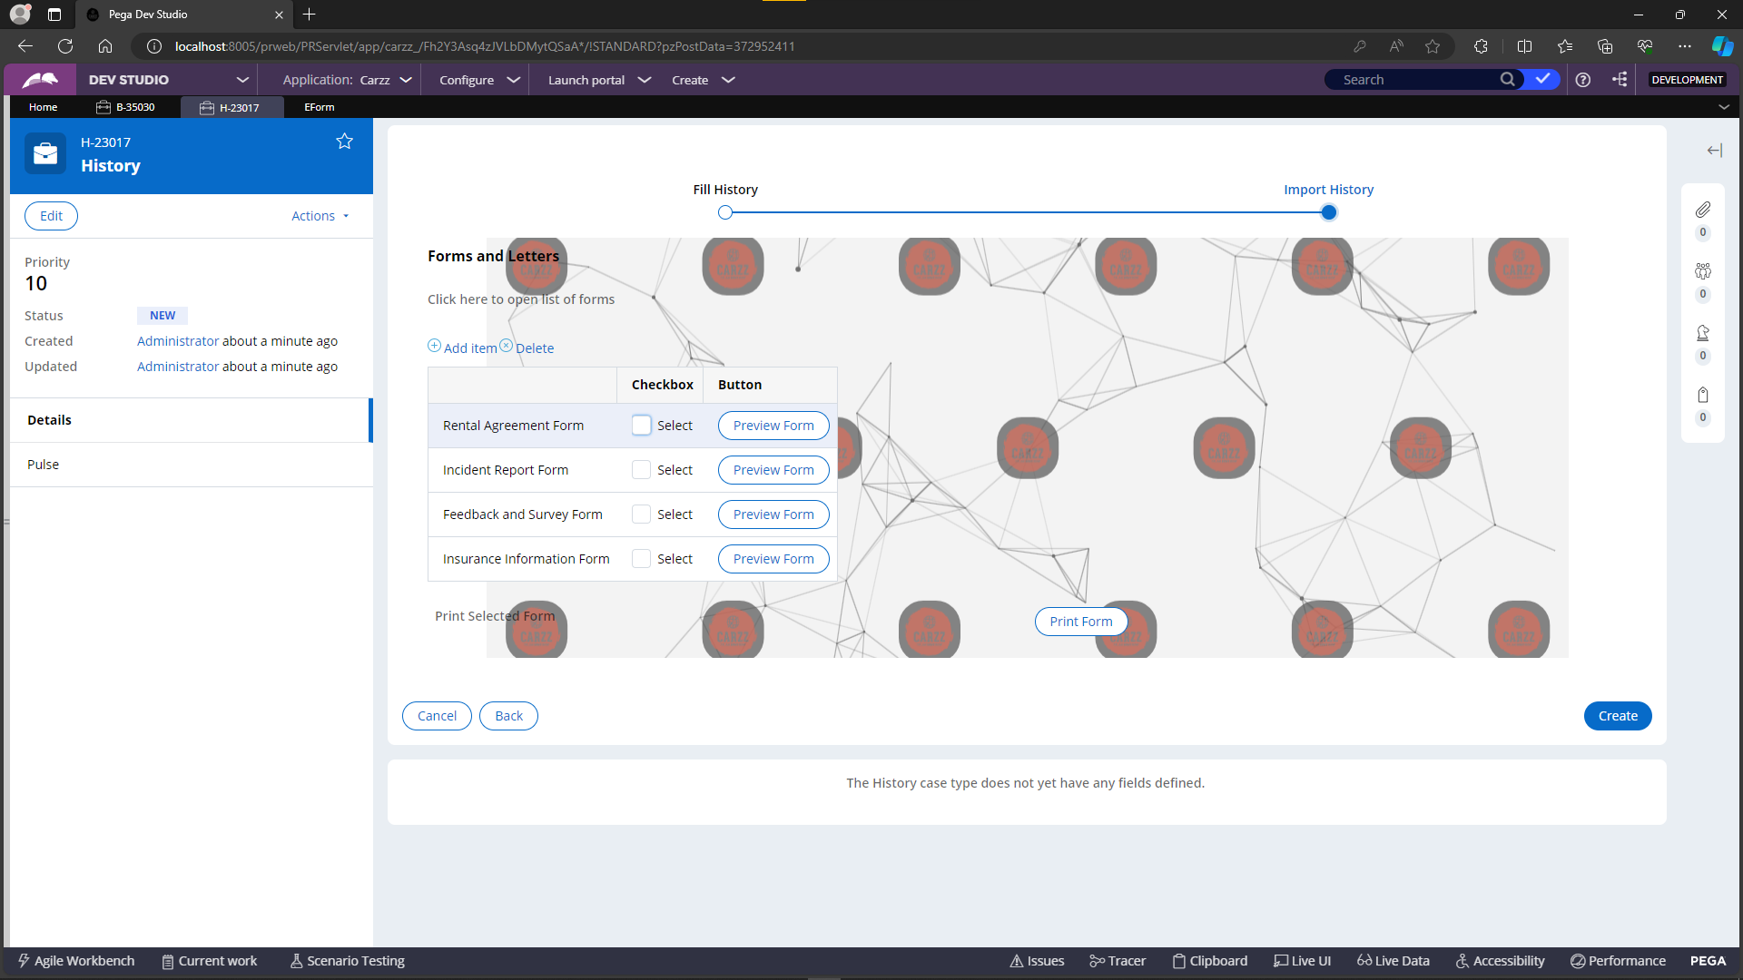

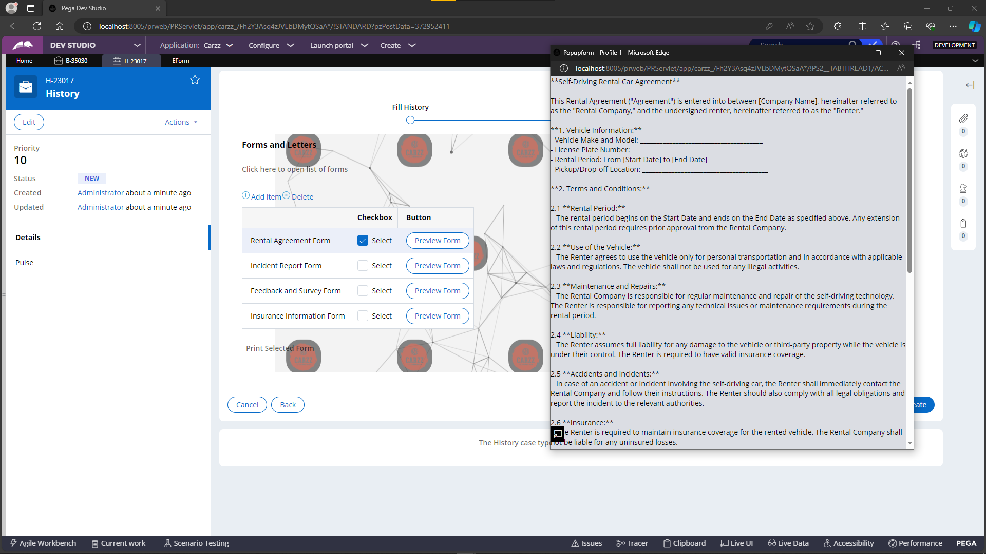

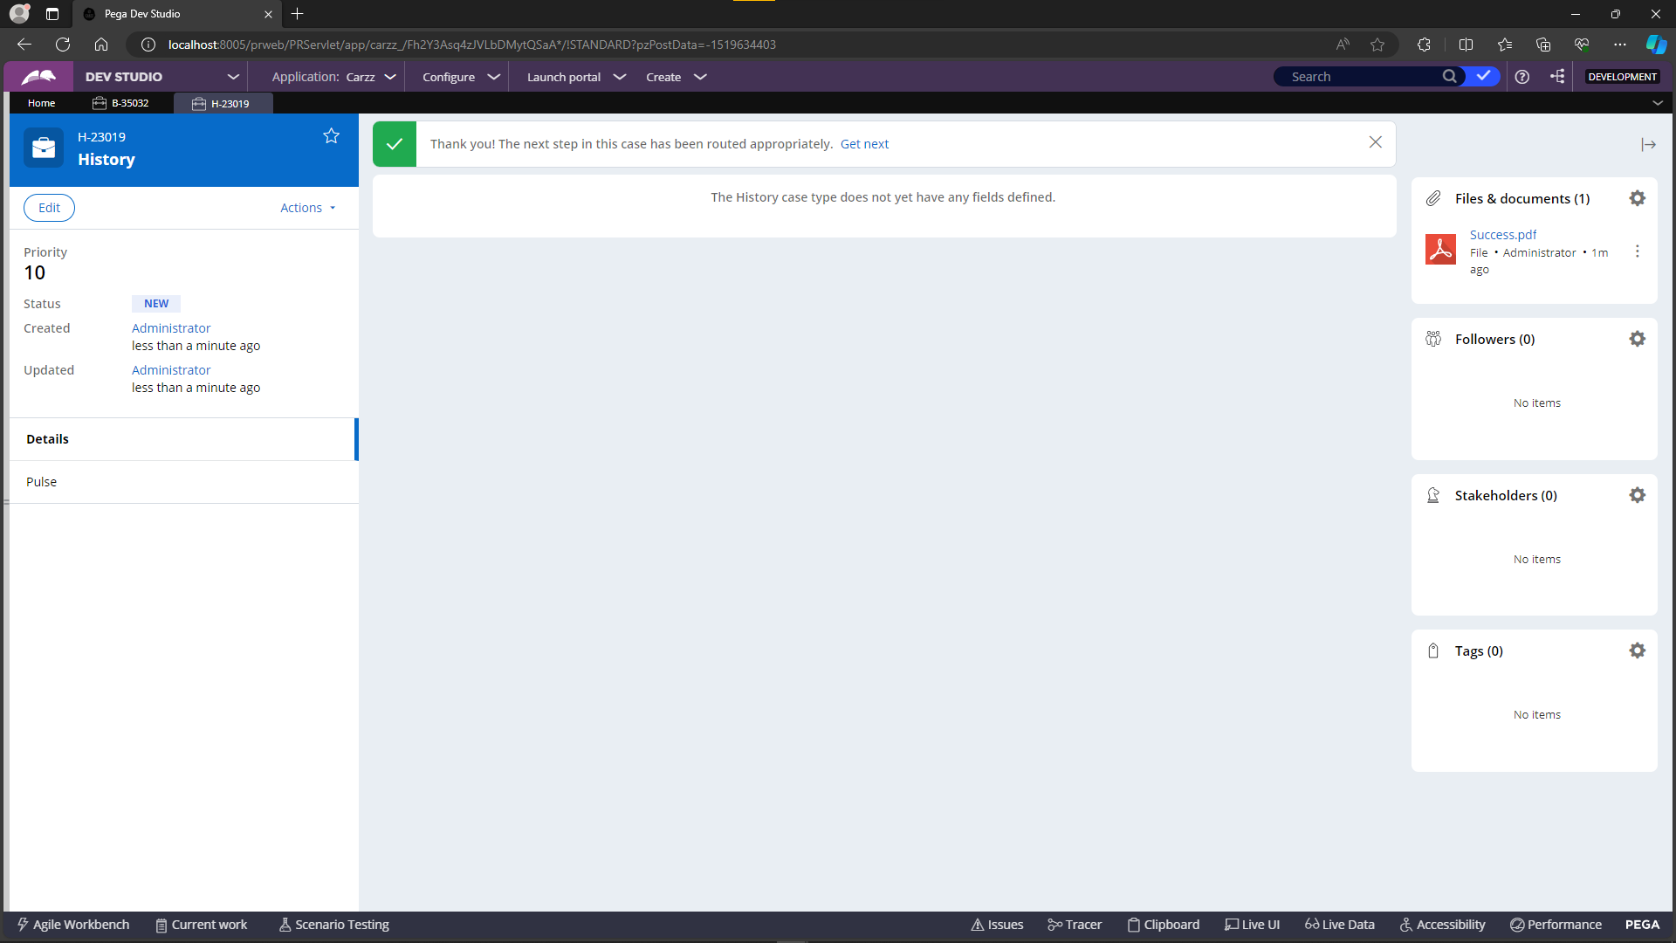

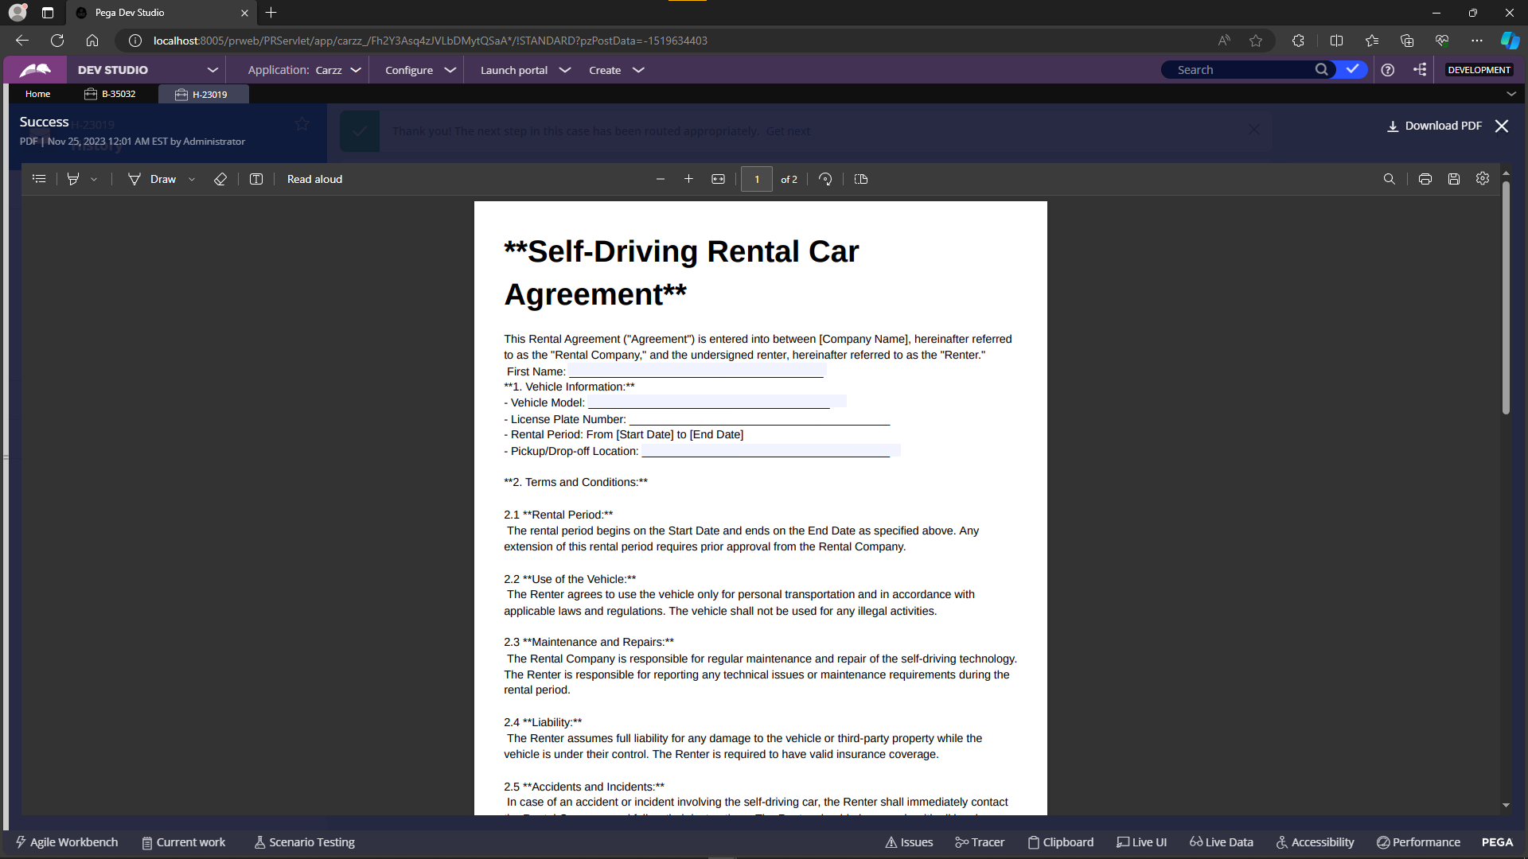

**7. Enhancements and Bug Fixes:**

**7.1 List of Enhancements:**

* Parsing excels and pdf.

**7.2 List of Bug Fixes:**

* Email listener picking old mails and creating the cases.

**8. System requirements:**

**Installation package**

The Personal Edition installation package includes these components:

* Java Runtime Environment (JRE)
* PostgreSQL
* Apache Tomcat
* Pega PlatformPersonal Edition

**Prerequisites**

Before installing the Personal Edition, confirm that your workstation meets the following prerequisites:

Intel-based personal computer or laptop with at least 4 GB of free RAM running a supported 64-bit version of Microsoft Windows. For information about supported versions, see the Platform Support Guide.

* 20 GB of free disk space for the following components:
* 5 GB for the downloaded files, which you can delete after installation
* 5 GB to extract the .zip files, which you can delete after installation
* 8 GB for the installed files, which may increase over time as you use the system

​A supported browser version:

* Microsoft Internet Explorer 9 or later
* Mozilla Firefox 5 or later
* Google Chrome 9 or later

**9. Project Sign-Off:**

[Project Name/Title] ____My POC 1.0________________________ Date: _____11/27/2023__________

**10. Conclusion:**

In conclusion, the understanding of all the major rules in Pega is crucial for the successful completion of Proof of Concept (POC) in the self-driving car application. With a solid understanding of Pega's rules and their implementation, the POC can effectively demonstrate the capabilities and efficiency of the self-driving car system. This understanding will enable efficient decision-making and rule configuration, ensuring the application meets all requirements and functions smoothly. By leveraging Pega's rule engine, the self-driving car application can effectively analyze and respond to various scenarios on the road, enhancing safety and optimizing performance. Therefore, a comprehensive understanding of Pega's rules is instrumental in creating a successful POC for the self-driving car application.

Thank you for choosing our Self-Driving Rental Car Application!